

**PUNJAB TIANJIN UNIVERISITY OF TECHNOLOGY**

**LAB MANUALS**

**SOFTWARE CONFIGRATION MANGEMENT(LAB)**

**(1-14)**

|  |  |
| --- | --- |
| **NAME** | **MUHAMMAD KHUBAIB** |
| **ROLL NO** | **23ST017** |
| **DEPARTMENT** | **SET-11** |
| **INSTRUCTOR** | **AFAQ AHMAD** |

**NAME**: MUHAMMAD KHUBAIB

**ROLL NO**: 23-ST-017

**DEPARTMENT**: SOFTWARE ENGINEERING TECHNOLOGY

LAB1

1. **Create a repository named “My Repo” and check the box of “Add a README file”.**

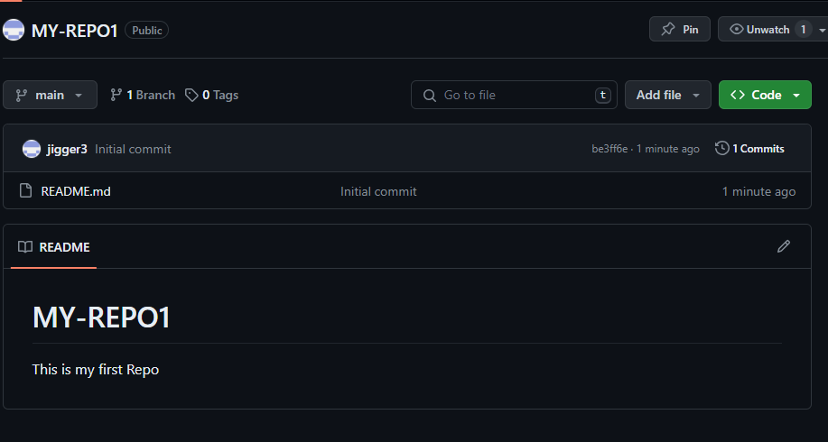

* In this I create a read me file and display its screenshot

**2.** **Add any description to your repo.**

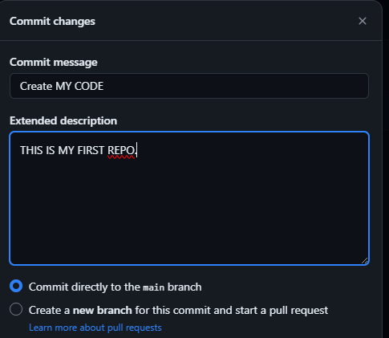

* In this show the description of the repo.

**3. Create a new file named “my_code”. Display your name using the cout command. Press the “Commit Changes” button. This will save your settings.**

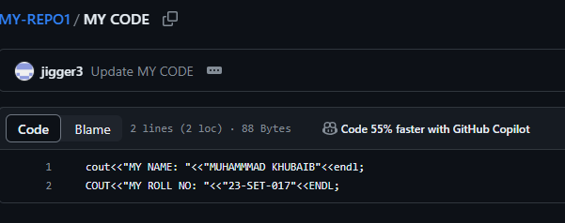

* In this I show the the name in the repo.
* In this we using C++.

**4. Attach the Network graph of your repo.**

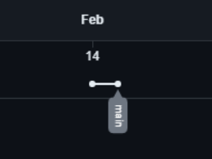

* In this we attach the screen shot of master file of repo.
* This file created first.

**5. Create a new branch named “Roll number”. Attach the screenshot**

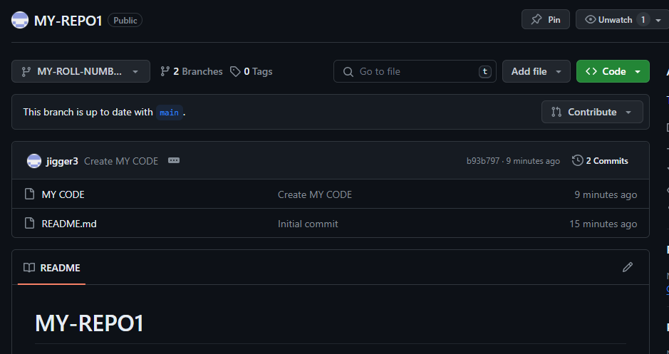

* In this I attach the screenshot of “new branch Roll Number”

**6. Go to your “Roll number” branch and add a new line in your code where you output your roll number using the cout command. Attach the network graph at this point.**

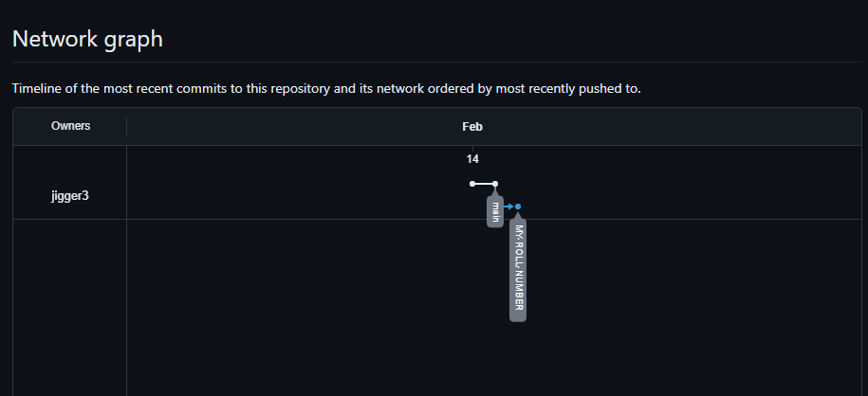

* In this I attach the screenshot of network graph adding with Roll Number.

**7. Commit your changes to the Roll number branch and attach the screenshot of your network graph.** 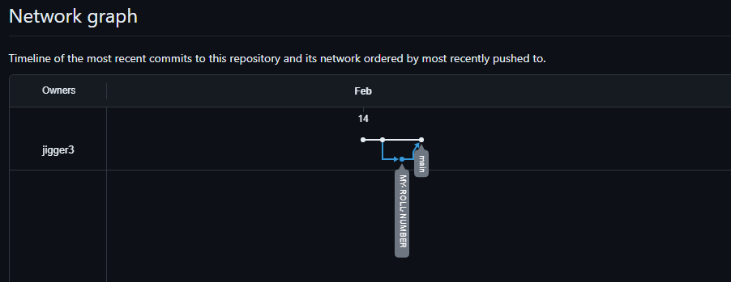

* In this attach the screenshot of network graph of commit your changing o to Roll No.

**8. Now, commit your changes to the master branch by creating and merging a PULL Request. Attach the screenshot of you creating and merging the PULL Request from the “Roll number” branch to Master branch.**

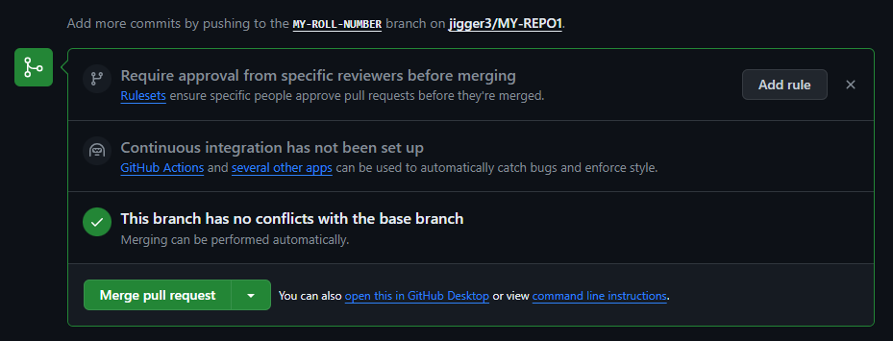

* In this I show the screenshot of pull request to merge master branch.

**9. Attach the final screenshot of your network graph after creating a branch and merging it in the master branch.**

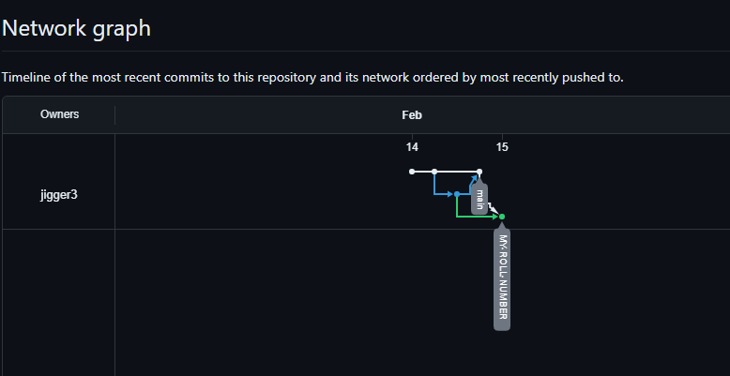

* In this I show the final merging network graph.

**GENERALIZED LAB RUBRICS**

|  |  |  |  |  |  |  |  |  |
| --- | --- | --- | --- | --- | --- | --- | --- | --- |
| **Domain** | **Component with Taxonomy** | **Above Expectation (4)** | **Meeting Expectation (3)** | **Approaching Expectation (2)** | **Below Expectation (1)** | **Used** | **Weight / 100**  **(Optional)** | **Score (1–4)** |
| **Psychomotor** | **Building (**Hardware) | Is able to build a given setup neatly and timely using correct hardware components and / or can reorganize / adapt to new / special requirements | Is able to assemble a given setup using correct hardware components after minor revisions | Is only able to copy a given setup using correct hardware components | Is not able to assemble a given setup using correct hardware components | ☐ |  |  |
| **Cognitive** | **Recording Measurements** (Hardware / Software) | Is able to record accurate measurements all the time | Is able to record accurate measurements most of the time | Is only able to record accurate measurements on some occasions | Is unable to record accurate measurements | ☐ |  |  |
| **Investigation**  (Software) | Is able to formulate /develop theories in addition to evaluating /concluding correctly about investigation parameters by assessing data | Is able to evaluate /conclude correctly about investigation parameters by assessing data | Is partially able to evaluate  /conclude correctly about investigation parameters by assessing data | Is unable to comprehend investigation parameters | ☐ |  |  |
| **Design / Development of Solution** (Hardware / Software) | Is able to design / develop the solution of a given problem and add features to it | Is able to design / develop the solution of a given problem | Is able to partially design / develop the solution of a given problem | Is unable to partially design  / develop the solution of a given problem | ☐ |  |  |
| **Software Usage**  (Software) | Is adept in the use of software tool and can access advanced features | Is able to use the software tool effectively by accessing all the required features | Is able to use the software tool but cannot access all the required features | Is unable to use the software tool | ☐ |  |  |
| **Programming Language** (Software) | Is able to efficiently complete a given task using advanced programming language constructs / methods / commands and/or add features to the original task | Is able to complete a given task using required programming language constructs / methods / commands | Is able to partially complete a given task | Is unable to partially complete a given task | ☐ |  |  |

**NAME: MUHAMMAD KHUBAIB**

**ROLL NO: 23ST017**

**DEPARTMENT: SOFTWARE ENGINEERING TECHNOLOGY**

**LAB2**

**CONCEPT OF GITHUB**

1. **Create a repo. Put any name you like.**

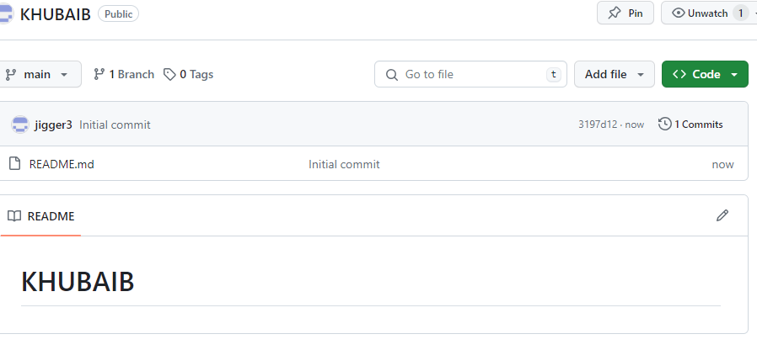

* **I Create new repo.**

**_______________________________________________________________________________**

1. **Create a file named “first_file”. Output your name and roll number using cout.**

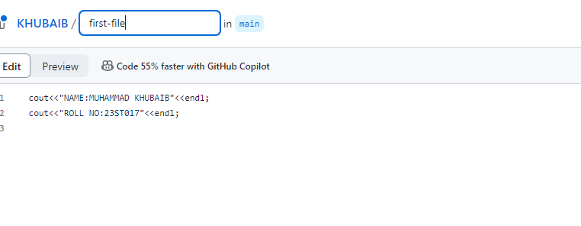

* **I created new file give name it first file.**
* **Next I print name and roll no**

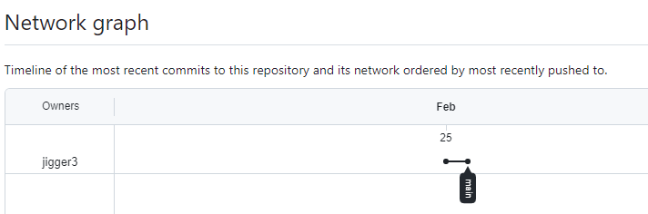**3. Attach you network graph.**

* **Network Graph**

**4 Create a new branch called “fsc_subjects”**

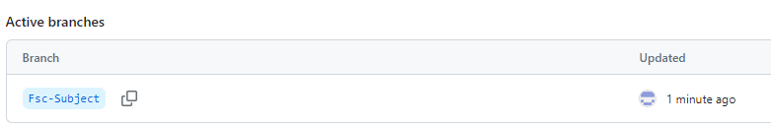

* **New Branch**

1. **Add your fsc subjects and commit to the fsc_subjects branch.**

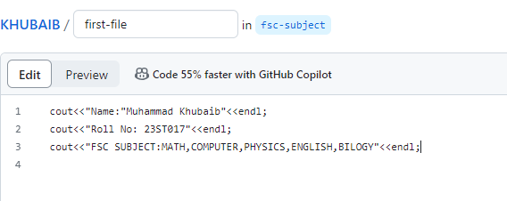

* **Edit new branch and add subject in the branch.**

1. **Create a new branch called “1st_semester”.**



**Create first semester branch.**

**__________________________________________________________________________________**

1. **Add your 1st semester subjects. Commit the changes to 1st_semster (NOT the master branch).**

**1-Semmester branch.**

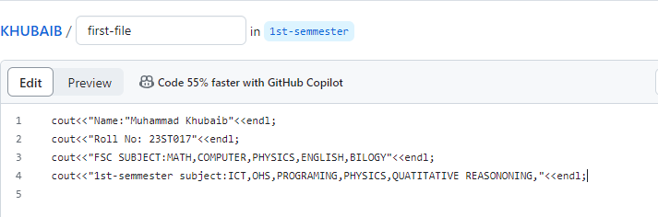

1. **Attach the network graph.**

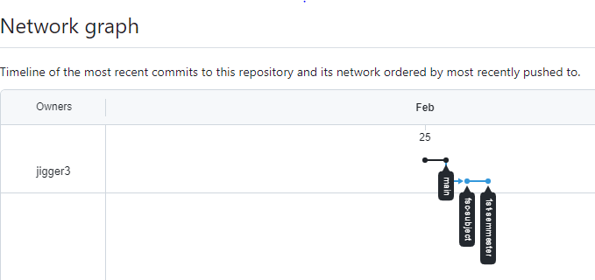

**Network Graph**

**9. Create a new branch named “2nd_semester”. Add your 2nd semester subjects in numbered**

**bullet points.**

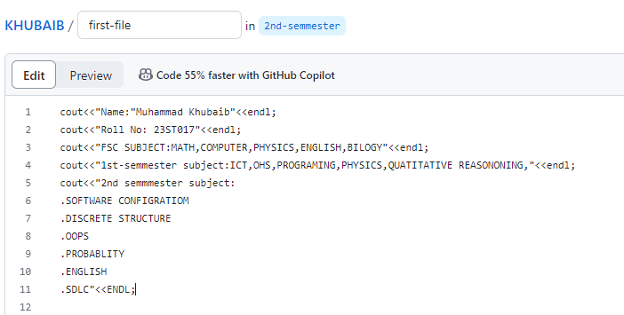

**Create 2nd semester branch give bulletes on its subject.**

**10. Attach the network graph.**

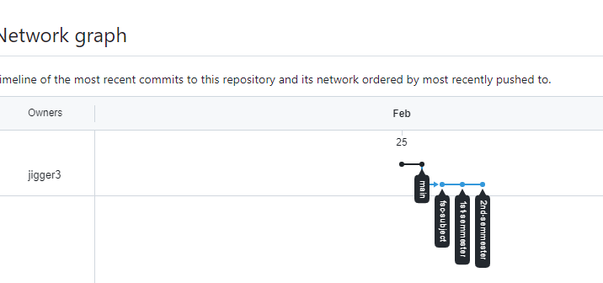

**Attach 2nd semester network graph.**

**11. Now, create and merge the 2nd_semester branch into the 1st semester branch. Attach the**

**Network graph.**

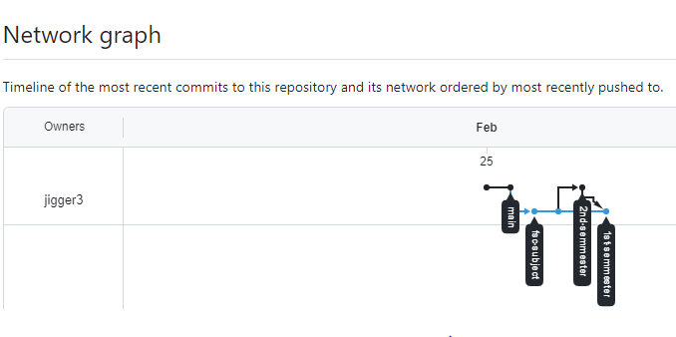

**Create merge and attach network graph.**

**12. After you merge the 2nd_semester branch, you should get a display like following:**

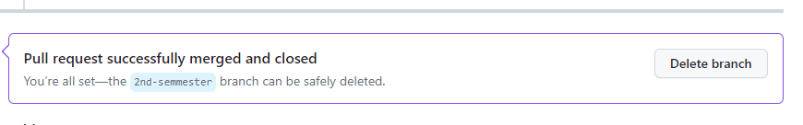

**13. Merge the 1st_semester into fsc_subjects. Attach the network graph after merging**

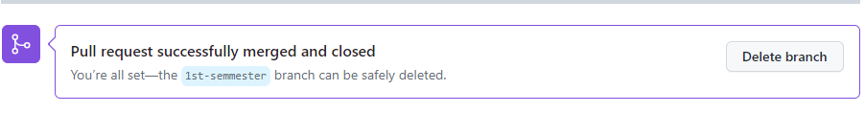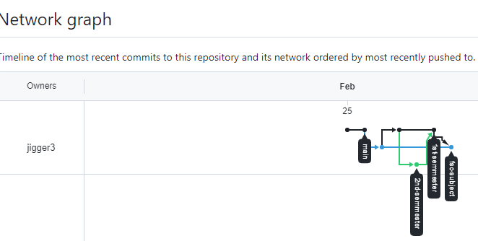

**Merge 1st-semmester into FSC Subject.**

**14. Finally, merge fsc_subjects to master branch.**

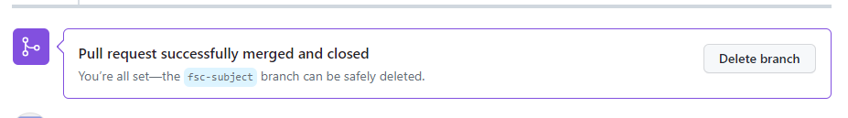

**15. Attach your network graph.**

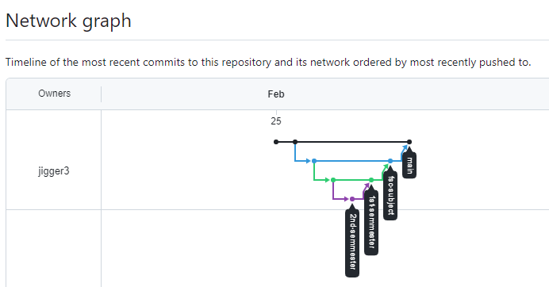

**Merge FSC Branch in Main Branch.**

**GENERALIZED LAB RUBRICS**

|  |  |  |  |  |  |  |  |  |
| --- | --- | --- | --- | --- | --- | --- | --- | --- |
| **Domain** | **Component with Taxonomy** | **Above Expectation (4)** | **Meeting Expectation (3)** | **Approaching Expectation (2)** | **Below Expectation (1)** | **Used** | **Weight / 100**  **(Optional)** | **Score (1–4)** |
| **Psychomotor** | **Building (**Hardware) | Is able to build a given setup neatly and timely using correct hardware components and / or can reorganize / adapt to new / special requirements | Is able to assemble a given setup using correct hardware components after minor revisions | Is only able to copy a given setup using correct hardware components | Is not able to assemble a given setup using correct hardware components | ☐ |  |  |
| **Cognitive** | **Recording Measurements** (Hardware / Software) | Is able to record accurate measurements all the time | Is able to record accurate measurements most of the time | Is only able to record accurate measurements on some occasions | Is unable to record accurate measurements | ☐ |  |  |
| **Investigation**  (Software) | Is able to formulate /develop theories in addition to evaluating /concluding correctly about investigation parameters by assessing data | Is able to evaluate /conclude correctly about investigation parameters by assessing data | Is partially able to evaluate  /conclude correctly about investigation parameters by assessing data | Is unable to comprehend investigation parameters | ☐ |  |  |
| **Design / Development of Solution** (Hardware / Software) | Is able to design / develop the solution of a given problem and add features to it | Is able to design / develop the solution of a given problem | Is able to partially design / develop the solution of a given problem | Is unable to partially design  / develop the solution of a given problem | ☐ |  |  |
| **Software Usage**  (Software) | Is adept in the use of software tool and can access advanced features | Is able to use the software tool effectively by accessing all the required features | Is able to use the software tool but cannot access all the required features | Is unable to use the software tool | ☐ |  |  |
| **Programming Language** (Software) | Is able to efficiently complete a given task using advanced programming language constructs / methods / commands and/or add features to the original task | Is able to complete a given task using required programming language constructs / methods / commands | Is able to partially complete a given task | Is unable to partially complete a given task | ☐ |  |  |

**NAME: MUHAMMAD KHUBAIB**

**ROLL NO: 23ST017**

**DEPARTMENT: SOFTWARE ENGINNERING TECHNOLOGY**

**LAB3**

1. **Add a file named “Calculator” in your main branch (main/calculator).**

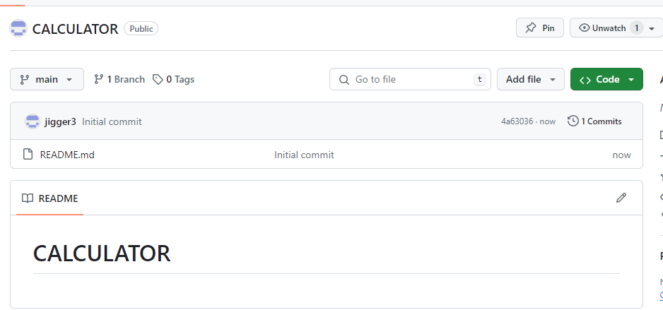

* Create a main branch with name Calculator.

__________________________________________________________________________

1. **In your main branch, add your name and roll number using a simple cout line (no need to write the whole program).**

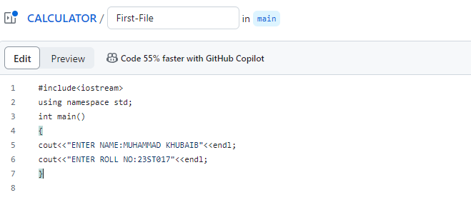

* In main branch we add Name and Roll No.

__________________________________________________________________________

**3.** **Commit these changes to the main branch.**

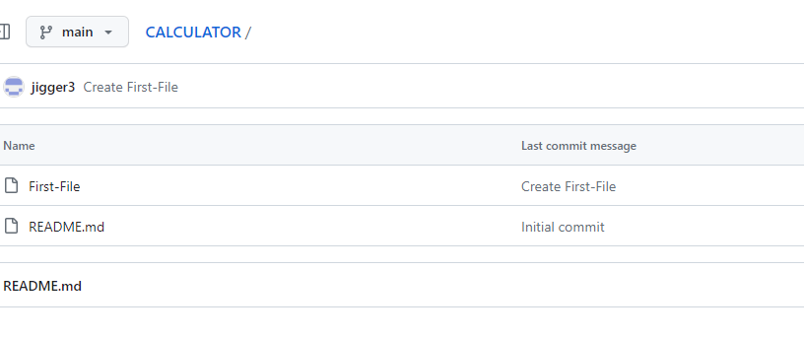

* Change commit and attach Screenshot.

__________________________________________________________________________

**4. In your addition\calculator, add a new line which simply adds two numbers ‘a’ and ‘b’,**

**using a single cout command.**

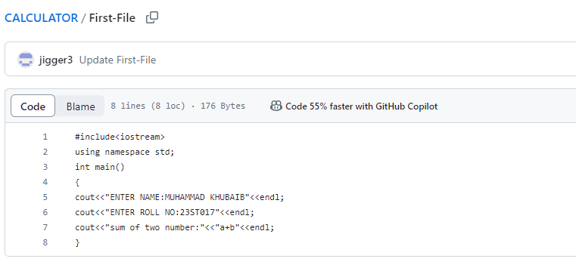

* Add addition Branch.

__________________________________________________________________________

**5. Create a new branch: “subtraction”.**

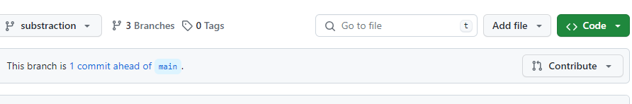

* Add new Branch subtraction.

__________________________________________________________________________

**6. In subtraction\calculator, add a cout line to subtract two numbers.** 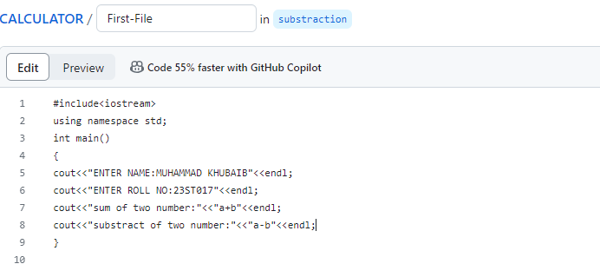

* Add news line subtraction of two number.

__________________________________________________________________________

**7. Commit to the subtraction branch**.

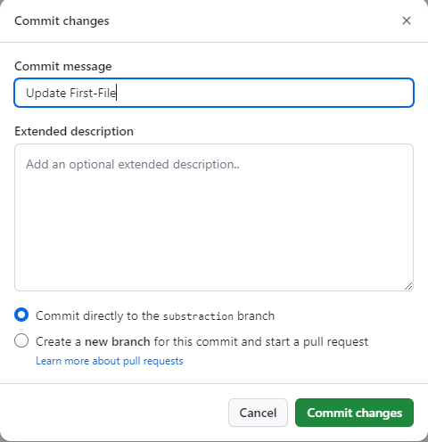

* Commit the subtraction branch.

__________________________________________________________________________

**8. Add a new branch: multiplication.**

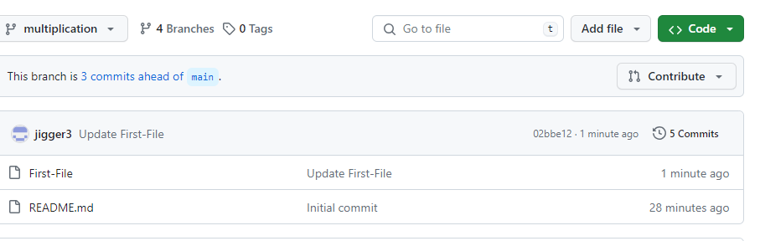

* Add multiplication branch.

__________________________________________________________________________

**9. In multiplication/calculator, add a line to calculate the product of the two numbers.**

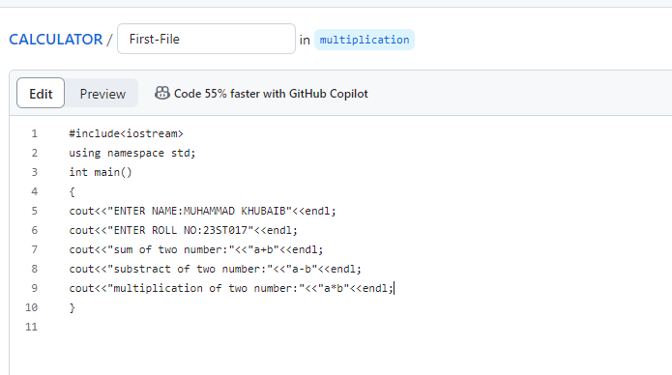

* Add new line for multiplication of two number.

__________________________________________________________________________

**10. Commit to the multiplication branch.** 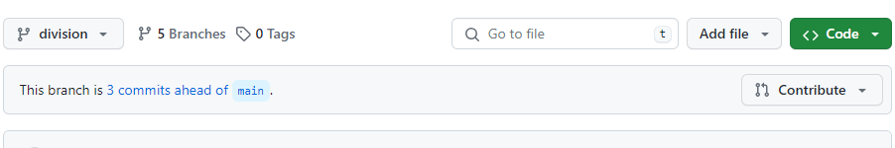

* Commit the multiplication branch.

__________________________________________________________________________

**11. Create a new branch: ‘division’.**



* Add division branch.

__________________________________________________________________________

**12. Add a line to calculate the division of two numbers: ‘a’ and ‘b’.**

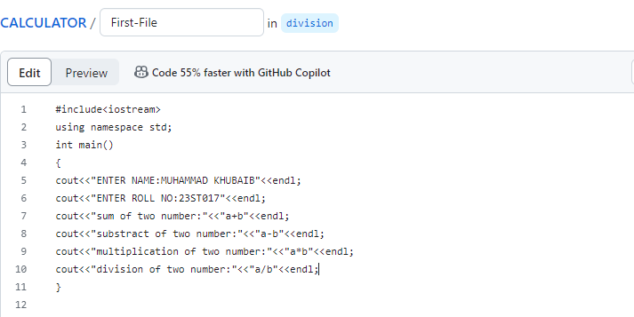

* Add new line for division.

__________________________________________________________________________**13. Commit to the division branch.**

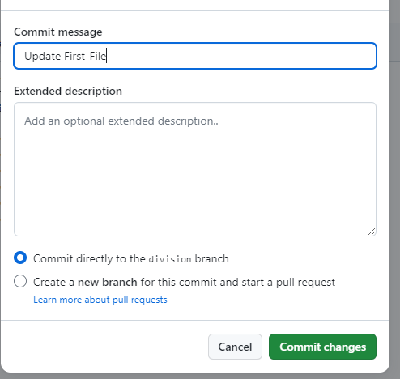

* Commit the division branch.

__________________________________________________________________________

**14. Create a PULL request to merge the division branch into the multiplication branch.**

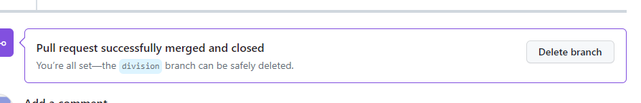

* Create pull request of division branch.

__________________________________________________________________________

**15. Attach the network graph at this point.**

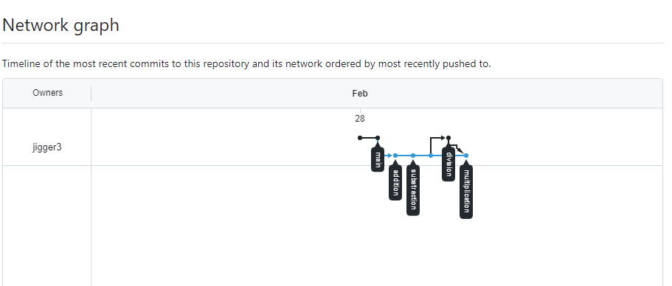

* Attach the network graph after merging division branch.

__________________________________________________________________________

**16. Merge the multiplication branch to the subtraction branch.**

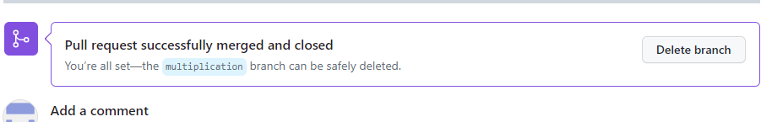

* Merge multiplication branch.

_________________________________________________________________________

**17. Attach the network graph.**

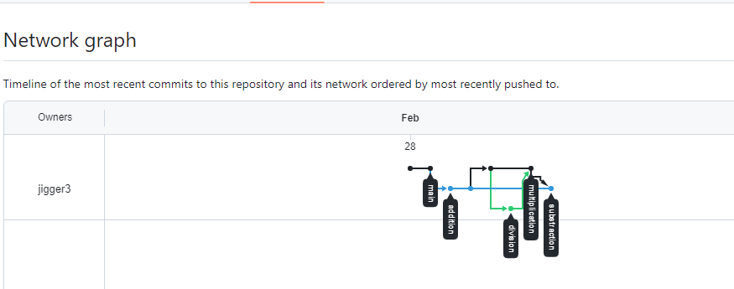

* Attach the network graph after merging multiplication branch.

_________________________________________________________________________

**18. Merge Subtraction to Addition branch.**

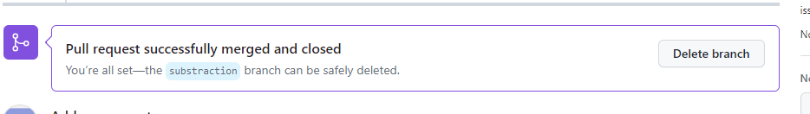

* Merge Subtraction branch.

_________________________________________________________________________

**19. Attach the network graph.**

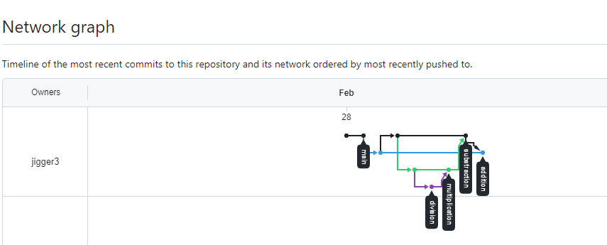

* Attach network graph after merge the Subtractions branch.

_________________________________________________________________________

**20. Finally, merge the addition to master branch.**

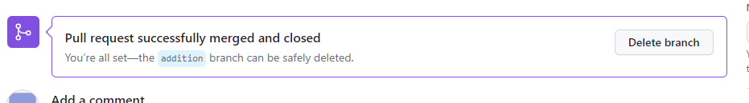

* Merge the addition branch.

_________________________________________________________________________

**21. Attach the network graph.**

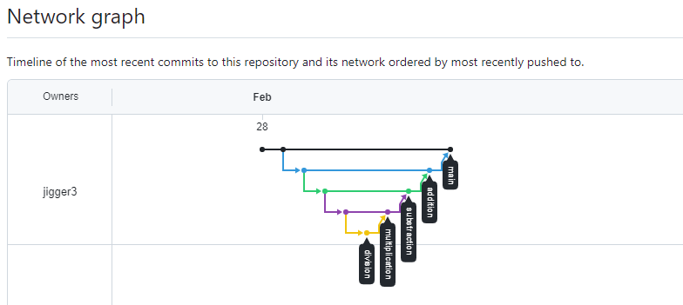

* Attach the network graph after merge the addition branch in main branch.

_________________________________________________________________________

**22. Attach the screenshots of the calculator file of the master branch and the addition**

**Branch. Is there any difference between the file contents?**

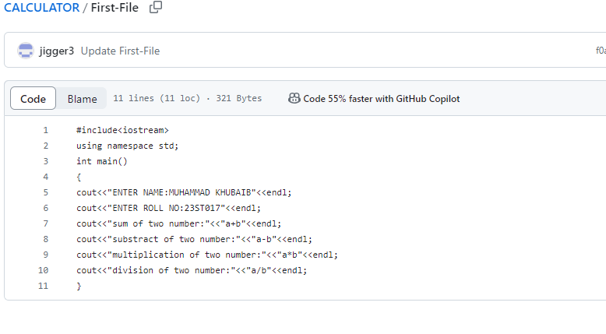

* Attach the Screenshot of merge all branch in master file.

________________________________________________________________________

**GENERALIZED LAB RUBRICS**

|  |  |  |  |  |  |  |  |  |
| --- | --- | --- | --- | --- | --- | --- | --- | --- |
| **Domain** | **Component with Taxonomy** | **Above Expectation (4)** | **Meeting Expectation (3)** | **Approaching Expectation (2)** | **Below Expectation (1)** | **Used** | **Weight / 100**  **(Optional)** | **Score (1–4)** |
| **Psychomotor** | **Building (**Hardware) | Is able to build a given setup neatly and timely using correct hardware components and / or can reorganize / adapt to new / special requirements | Is able to assemble a given setup using correct hardware components after minor revisions | Is only able to copy a given setup using correct hardware components | Is not able to assemble a given setup using correct hardware components | ☐ |  |  |
| **Cognitive** | **Recording Measurements** (Hardware / Software) | Is able to record accurate measurements all the time | Is able to record accurate measurements most of the time | Is only able to record accurate measurements on some occasions | Is unable to record accurate measurements | ☐ |  |  |
| **Investigation**  (Software) | Is able to formulate /develop theories in addition to evaluating /concluding correctly about investigation parameters by assessing data | Is able to evaluate /conclude correctly about investigation parameters by assessing data | Is partially able to evaluate  /conclude correctly about investigation parameters by assessing data | Is unable to comprehend investigation parameters | ☐ |  |  |
| **Design / Development of Solution** (Hardware / Software) | Is able to design / develop the solution of a given problem and add features to it | Is able to design / develop the solution of a given problem | Is able to partially design / develop the solution of a given problem | Is unable to partially design  / develop the solution of a given problem | ☐ |  |  |
| **Software Usage**  (Software) | Is adept in the use of software tool and can access advanced features | Is able to use the software tool effectively by accessing all the required features | Is able to use the software tool but cannot access all the required features | Is unable to use the software tool | ☐ |  |  |
| **Programming Language** (Software) | Is able to efficiently complete a given task using advanced programming language constructs / methods / commands and/or add features to the original task | Is able to complete a given task using required programming language constructs / methods / commands | Is able to partially complete a given task | Is unable to partially complete a given task | ☐ |  |  |

**NAME: MUHAMMAD KHUBAIB**

**ROLL NO: 23ST017**

**DEPARTMENT: SOFTWARE ENGINEERING TECHNOLOGY**

**LAB4**

1. **Create a file named “my_first_file” in the master/main branch.**

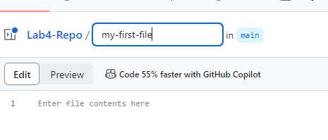

* Create my first file.

1. **Add a C++ line to add two numbers. Commit the changes to the master branch.**

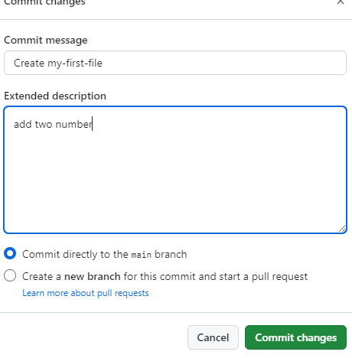

* Commit change after adding two lines.

1. **Attach your network graph.** 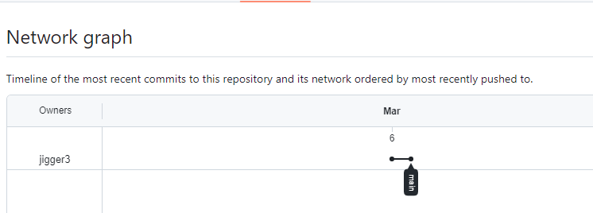

* Network Graph.

1. **Create a new branch named “feather” from main branch.** 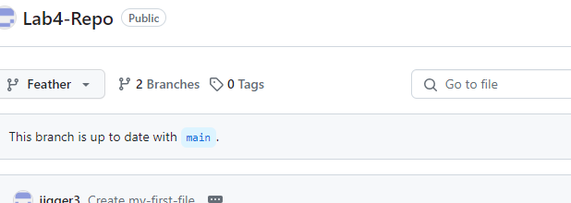

* Create feather name branch.

1. **Create a new branch named “models” from main.**

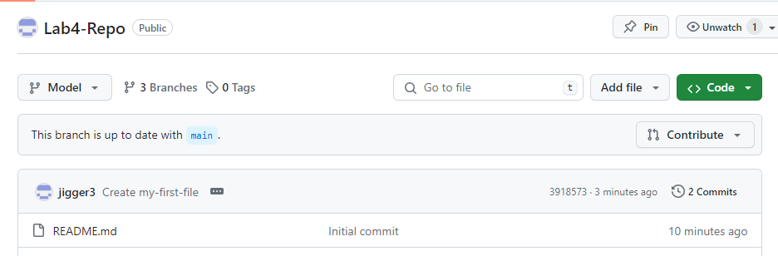

* Create model name branch.

1. **Attach the network graph.** 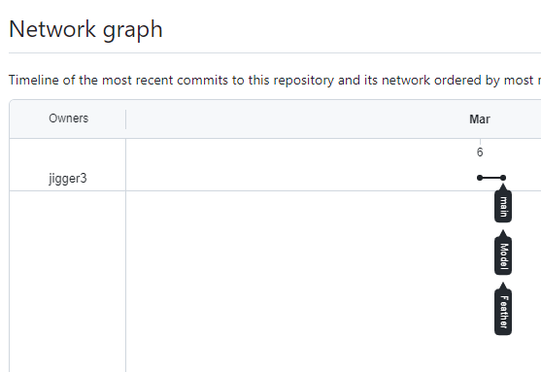

* Attach Network Graph after create two branch from main.

1. 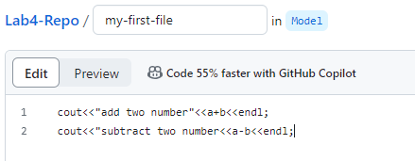**In the ‘models’ branch, add a new code to subtract two numbers.**

* Subtaract two number code add in the model branch.

**8. Commit the changes to the models branch.**

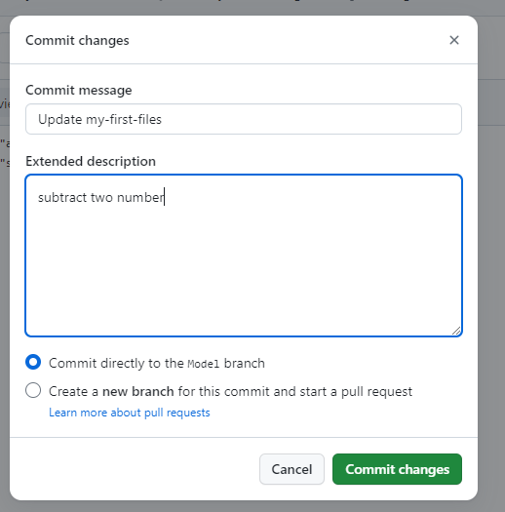

* Commit the model branch.

1. **Attach the network graph.**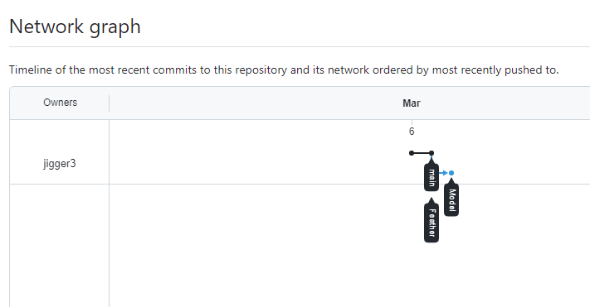

* Attach Network branch after commit the model branch.

1. **Go to the “Pull Requests” tab and add a PULL request to merge the ‘models’ to the ‘main’ branch.** 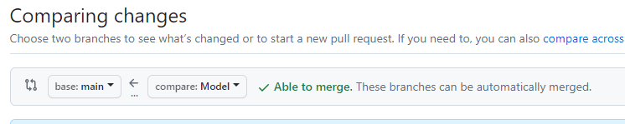

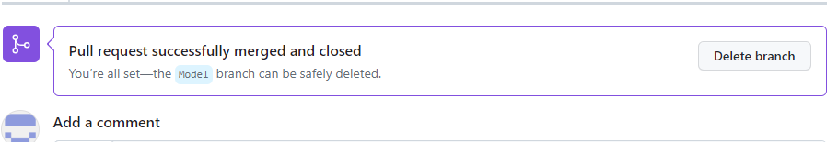

* Create pull request for mergingmodel branch to the main branch.

**At this point, you did not merge the features branch to the main branch**

1. **Add a screenshot showing the contents of my_first_file of the main branch and the features branch. What is the difference?** 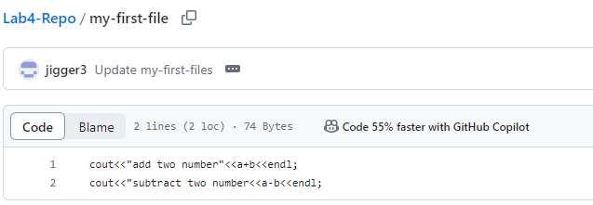

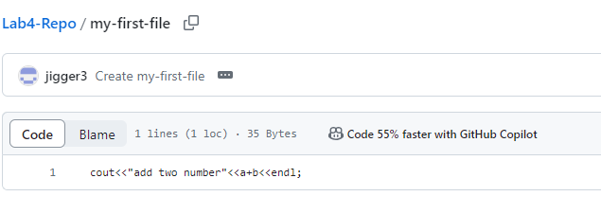

* Show difference Feather branch and the main branch.

1. **Do carefully: Merge the ‘models’ branch to the ‘features’ branch. Commit the change to the ‘features’ branch.**

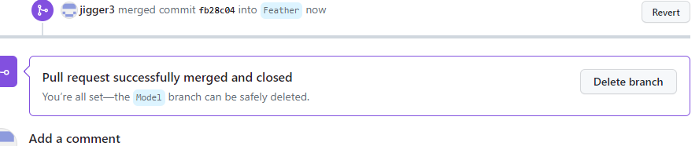

* Merge model branch into feather branch.

1. **Add a line that outputs the product of two number.**

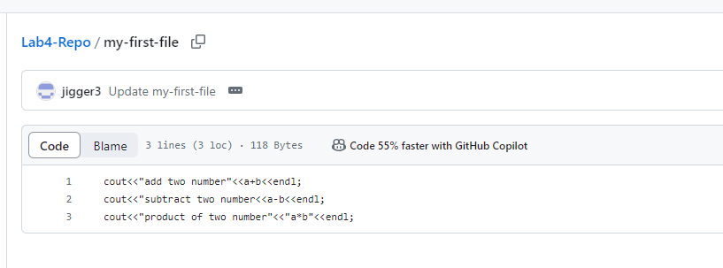

* Add line product of two number in the feather branch.

1. **Attach the network graph.**

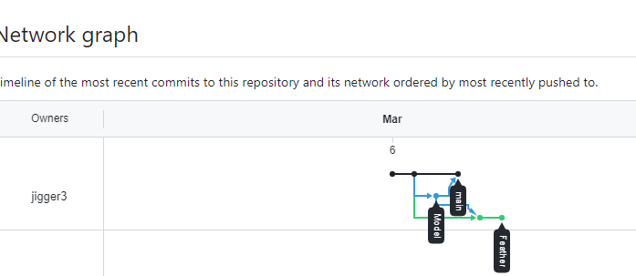

* Network Graph

1. **Add a screenshot showing the contents of my_first_file of the features branch, models branch and main branch. Is there any similarity or difference? Explain your findings.** 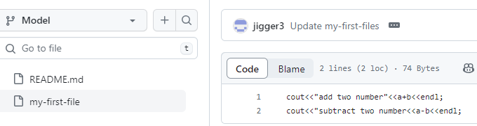

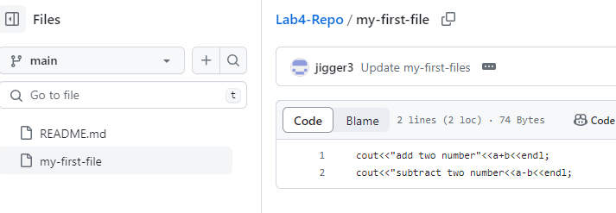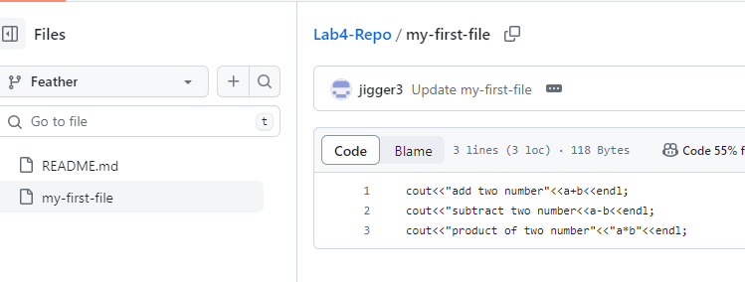

* We merge the model branch in the feather branch feather branch contain three line code but model branch and main are merged contain two line code.

1. **Attach the final network graph.**

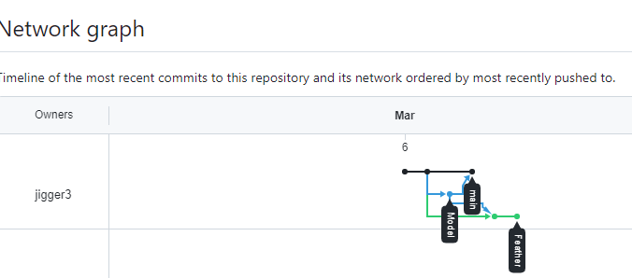

* Final Network Graph.

**GENERALIZED LAB RUBRICS**

|  |  |  |  |  |  |  |  |  |
| --- | --- | --- | --- | --- | --- | --- | --- | --- |
| **Domain** | **Component with Taxonomy** | **Above Expectation (4)** | **Meeting Expectation (3)** | **Approaching Expectation (2)** | **Below Expectation (1)** | **Used** | **Weight / 100**  **(Optional)** | **Score (1–4)** |
| **Psychomotor** | **Building (**Hardware) | Is able to build a given setup neatly and timely using correct hardware components and / or can reorganize / adapt to new / special requirements | Is able to assemble a given setup using correct hardware components after minor revisions | Is only able to copy a given setup using correct hardware components | Is not able to assemble a given setup using correct hardware components | ☐ |  |  |
| **Cognitive** | **Recording Measurements** (Hardware / Software) | Is able to record accurate measurements all the time | Is able to record accurate measurements most of the time | Is only able to record accurate measurements on some occasions | Is unable to record accurate measurements | ☐ |  |  |
| **Investigation**  (Software) | Is able to formulate /develop theories in addition to evaluating /concluding correctly about investigation parameters by assessing data | Is able to evaluate /conclude correctly about investigation parameters by assessing data | Is partially able to evaluate  /conclude correctly about investigation parameters by assessing data | Is unable to comprehend investigation parameters | ☐ |  |  |
| **Design / Development of Solution** (Hardware / Software) | Is able to design / develop the solution of a given problem and add features to it | Is able to design / develop the solution of a given problem | Is able to partially design / develop the solution of a given problem | Is unable to partially design  / develop the solution of a given problem | ☐ |  |  |
| **Software Usage**  (Software) | Is adept in the use of software tool and can access advanced features | Is able to use the software tool effectively by accessing all the required features | Is able to use the software tool but cannot access all the required features | Is unable to use the software tool | ☐ |  |  |
| **Programming Language** (Software) | Is able to efficiently complete a given task using advanced programming language constructs / methods / commands and/or add features to the original task | Is able to complete a given task using required programming language constructs / methods / commands | Is able to partially complete a given task | Is unable to partially complete a given task | ☐ |  |  |

**NAME: MUHAMMAD KHUBAIB**

**ROLL NO: 23ST017**

**DEPARTMENT: SOFTWARE ENGINEERING TECHNOLOGY**

**LAB5**

1. **Using your GitHub account, find any interesting repo and ‘fork’ it.**

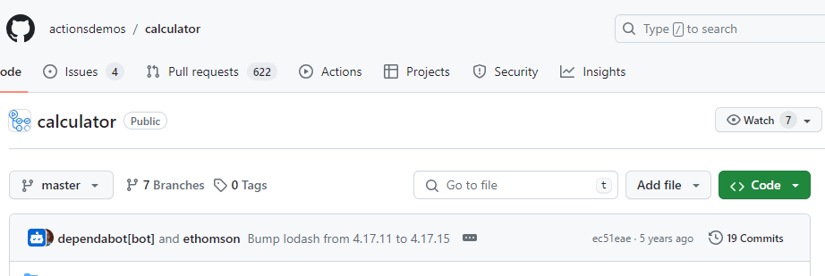

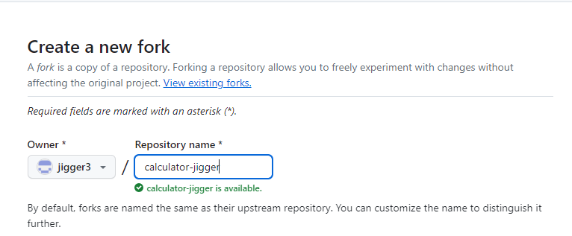

* **Find repo and work on fork.**

1. **After you fork it, attach a screenshot of its main repo where all of its files and folders are displayed.** 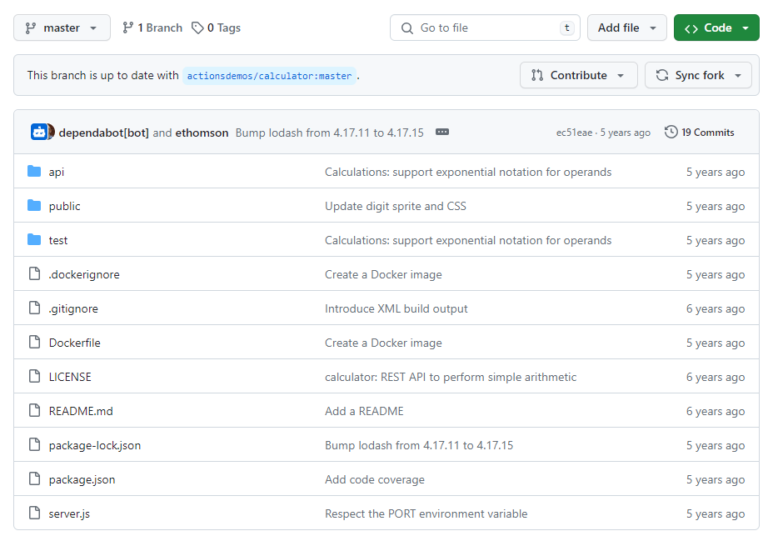

* **Screenshot who folder and file display.**

1. **Locate the main source code of the program and try to modify your own version by adding a simple cout command that adds two numbers.**

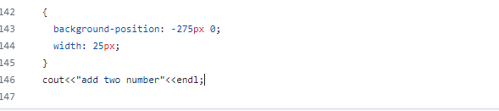

* **Add one code in the calculator fork.**

1. **Submit a PULL Request to the owner of the repo.**

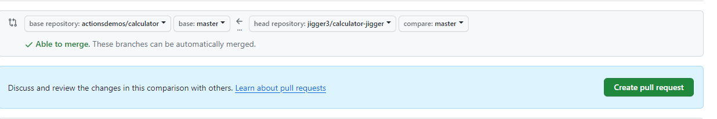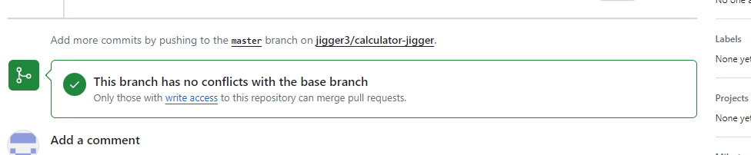

* **Submit pull request to the owner of the repo.**

1. **Next, fork the repo of any of your friend.**

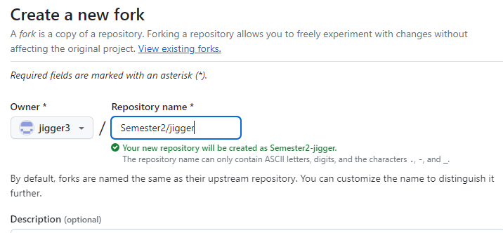

* **Fork repo of friend.**

**6. By adding any new file, submit a PULL request to him. This will let him know that a new**

**edit has been made and needs reviewing.**

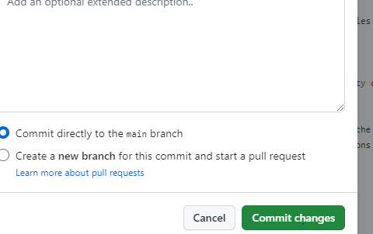

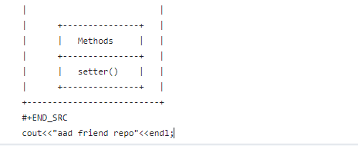

**After changes pull request to friend repo.**

1. **Finally, ‘fork’ the main repo and add a new file.**

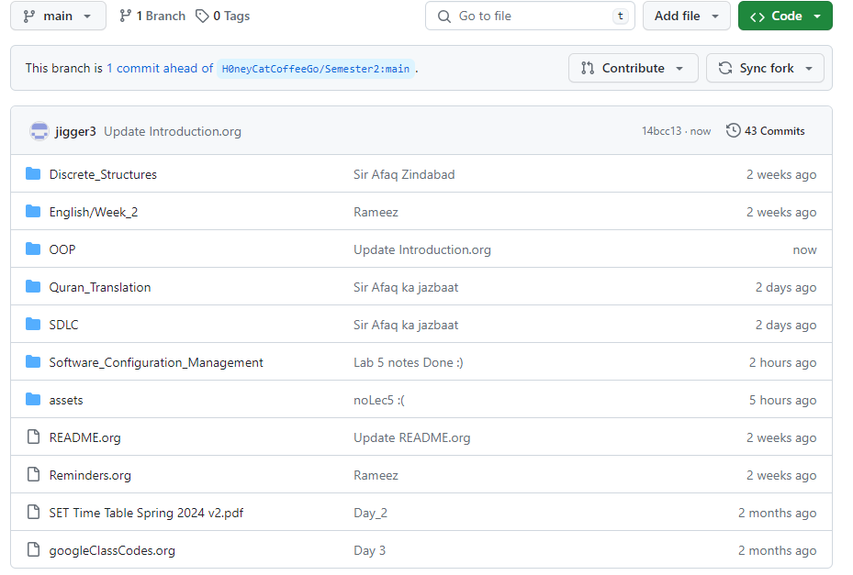

* **Finnally fork.**

1. **In your file, add a line that prints your name, roll number and department using**

**simple cout command.**

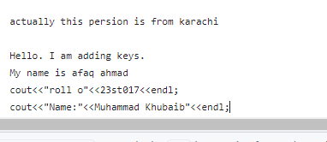

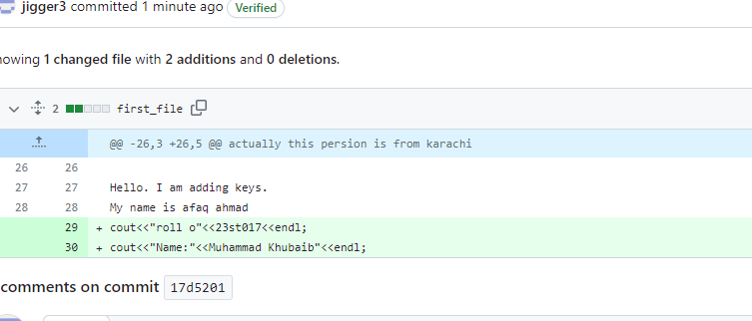

* **In this I fork the your repo for attendance.**

**GENERALIZED LAB RUBRICS**

|  |  |  |  |  |  |  |  |  |
| --- | --- | --- | --- | --- | --- | --- | --- | --- |
| **Domain** | **Component with Taxonomy** | **Above Expectation (4)** | **Meeting Expectation (3)** | **Approaching Expectation (2)** | **Below Expectation (1)** | **Used** | **Weight / 100**  **(Optional)** | **Score (1–4)** |
| **Psychomotor** | **Building (**Hardware) | Is able to build a given setup neatly and timely using correct hardware components and / or can reorganize / adapt to new / special requirements | Is able to assemble a given setup using correct hardware components after minor revisions | Is only able to copy a given setup using correct hardware components | Is not able to assemble a given setup using correct hardware components | ☐ |  |  |
| **Cognitive** | **Recording Measurements** (Hardware / Software) | Is able to record accurate measurements all the time | Is able to record accurate measurements most of the time | Is only able to record accurate measurements on some occasions | Is unable to record accurate measurements | ☐ |  |  |
| **Investigation**  (Software) | Is able to formulate /develop theories in addition to evaluating /concluding correctly about investigation parameters by assessing data | Is able to evaluate /conclude correctly about investigation parameters by assessing data | Is partially able to evaluate  /conclude correctly about investigation parameters by assessing data | Is unable to comprehend investigation parameters | ☐ |  |  |
| **Design / Development of Solution** (Hardware / Software) | Is able to design / develop the solution of a given problem and add features to it | Is able to design / develop the solution of a given problem | Is able to partially design / develop the solution of a given problem | Is unable to partially design  / develop the solution of a given problem | ☐ |  |  |
| **Software Usage**  (Software) | Is adept in the use of software tool and can access advanced features | Is able to use the software tool effectively by accessing all the required features | Is able to use the software tool but cannot access all the required features | Is unable to use the software tool | ☐ |  |  |
| **Programming Language** (Software) | Is able to efficiently complete a given task using advanced programming language constructs / methods / commands and/or add features to the original task | Is able to complete a given task using required programming language constructs / methods / commands | Is able to partially complete a given task | Is unable to partially complete a given task | ☐ |  |  |

**NAME: MUHAMMAD KHUBAIB**

**ROLLNO: 23ST017**

**DEPARTMENT: SOFTWARE ENGINNERING TECHNOLOGY**

LAB6

1. **Create a new file in your “Lab 6” repo.**

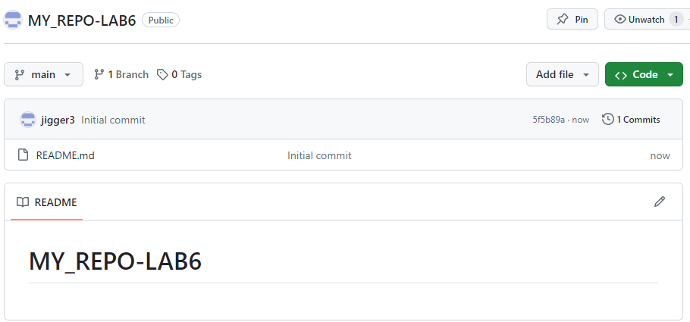

* Create new file named as My_Repo/Lab6.

1. **In your file, add a list of any five grocery items (look at the figure).**

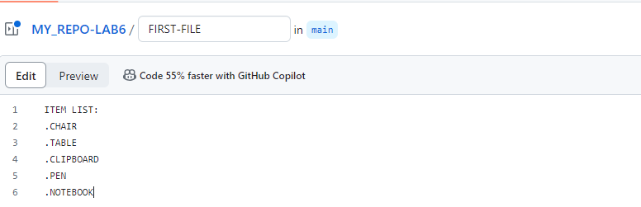

* Add glossary item in the main file.

1. **Commit it to the main branch.**

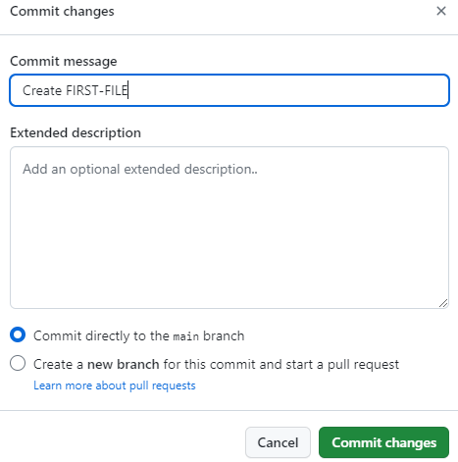

Commit changes after add glossary item.

1. **Create new branches named ‘1 st _branch’ and ‘2 nd _branch’ from the main branch.**

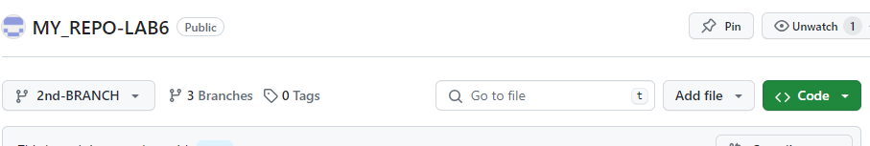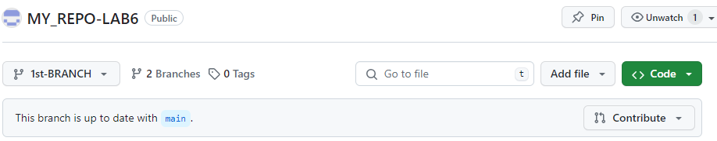

* Create two branch from main named as 1st-branch and 2nd branch.

1. **Attach network graph.**

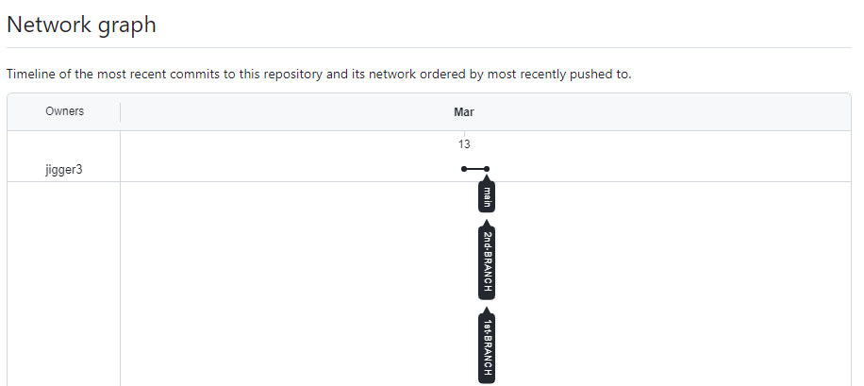

* Attach network graph.

1. **Go to your file in the first branch and add a new item (any item you like) in the 9 th line. Commit directly to main branch**.

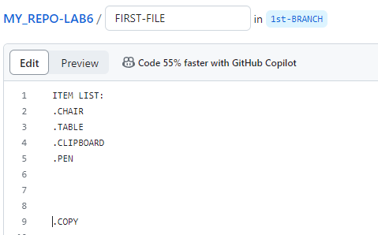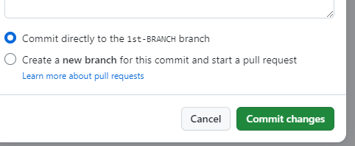

* Add the 1 glossary item in the ist branch and commit it to main.

1. **Go to your 2nd _branch. Add a new item in the (same) 9th line of that file**.

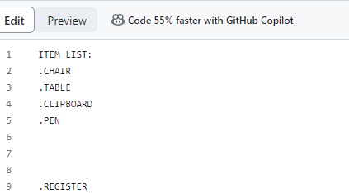

* Add 1 glossary item to main and commit it to main.

1. **Generate a PULL request to merge 1 st _branch to main branch. Attach its screenshot.**

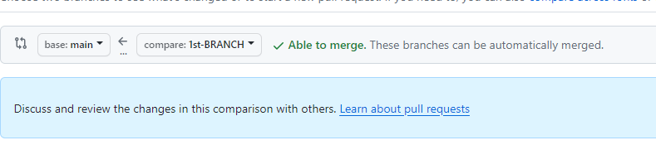

* Merge 1st branch to main branch.

1. **Accept the PULL request i.e. merge the 1 st _branch to the main branch.**

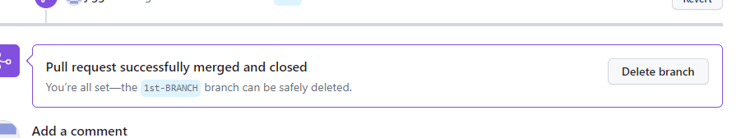

* Accept the pull request to merge 1st branch in main.

1. **Attach the network graph**.

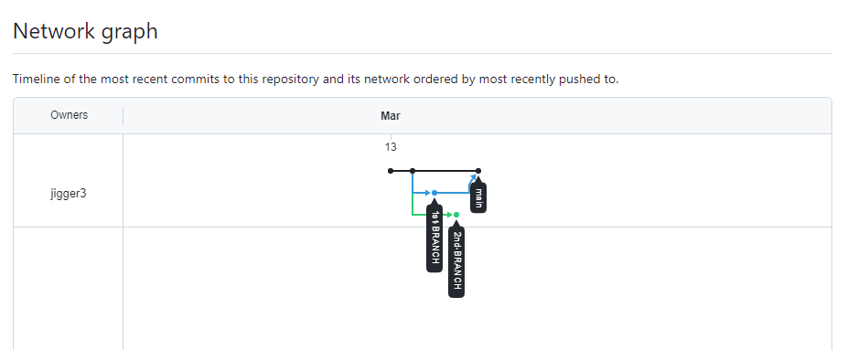

* After merge 1st branch into main attach screenshot of network graph.

1. **Now, merge the 2nd branch to main branch. You will get an error message:**

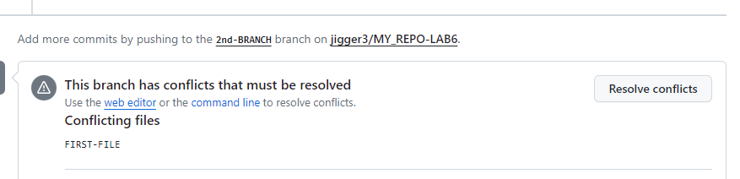

* Merge 2nd branch into main.

1. **Resolve the issue by opening the new window. Then click the “Resolve commit” button.**

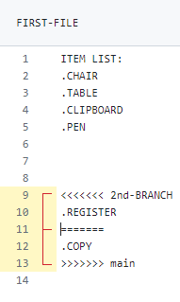

* Click on the resolve clivk button and remove the error.

1. **Finally merge and delete your 2nd _branch.**

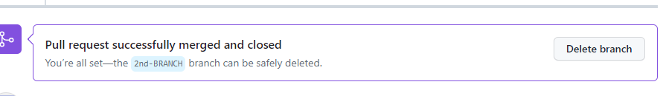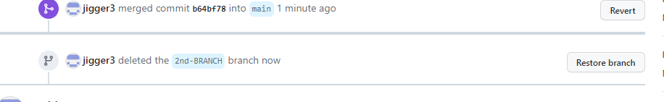

* After resolve the issue I merge the 2nd branch into main.

1. **Attach your network graph.**

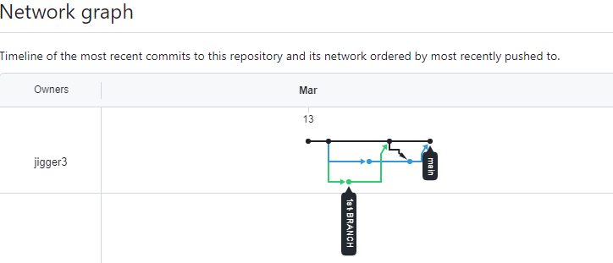

* After resolve and merge the 2nd branch into main attach the network graph screenshot.

1. **In the end of your lab, write a conclusion of what you learnt in this lab so far.**

* I create two branch in the main.
* I add new item in the list.
* When we merge the 2nd branch in the main it create a conflict erroe.
* Then I remove error.
* I learnt how we can resolve issues while working with complex branches.
* I know the concept of resolve conflict.

**GENERALIZED LAB RUBRICS**

|  |  |  |  |  |  |  |  |  |
| --- | --- | --- | --- | --- | --- | --- | --- | --- |
| **Domain** | **Component with Taxonomy** | **Above Expectation (4)** | **Meeting Expectation (3)** | **Approaching Expectation (2)** | **Below Expectation (1)** | **Used** | **Weight / 100**  **(Optional)** | **Score (1–4)** |
| **Psychomotor** | **Building (**Hardware) | Is able to build a given setup neatly and timely using correct hardware components and / or can reorganize / adapt to new / special requirements | Is able to assemble a given setup using correct hardware components after minor revisions | Is only able to copy a given setup using correct hardware components | Is not able to assemble a given setup using correct hardware components | ☐ |  |  |
| **Cognitive** | **Recording Measurements** (Hardware / Software) | Is able to record accurate measurements all the time | Is able to record accurate measurements most of the time | Is only able to record accurate measurements on some occasions | Is unable to record accurate measurements | ☐ |  |  |
| **Investigation**  (Software) | Is able to formulate /develop theories in addition to evaluating /concluding correctly about investigation parameters by assessing data | Is able to evaluate /conclude correctly about investigation parameters by assessing data | Is partially able to evaluate  /conclude correctly about investigation parameters by assessing data | Is unable to comprehend investigation parameters | ☐ |  |  |
| **Design / Development of Solution** (Hardware / Software) | Is able to design / develop the solution of a given problem and add features to it | Is able to design / develop the solution of a given problem | Is able to partially design / develop the solution of a given problem | Is unable to partially design  / develop the solution of a given problem | ☐ |  |  |
| **Software Usage**  (Software) | Is adept in the use of software tool and can access advanced features | Is able to use the software tool effectively by accessing all the required features | Is able to use the software tool but cannot access all the required features | Is unable to use the software tool | ☐ |  |  |
| **Programming Language** (Software) | Is able to efficiently complete a given task using advanced programming language constructs / methods / commands and/or add features to the original task | Is able to complete a given task using required programming language constructs / methods / commands | Is able to partially complete a given task | Is unable to partially complete a given task | ☐ |  |  |

**NAME: MUHAMMAD KHUBAIB**

**ROLL NO: 23ST017**

**DEPARTMENT: SOFTWARE ENGINNERING TECHNOLOGY**

**LAB 7**

**GITHUB ISSUES AND COMMIT**

**__________________________________________________________________________**

1. **Create a new repo named ‘Lab 7’.**

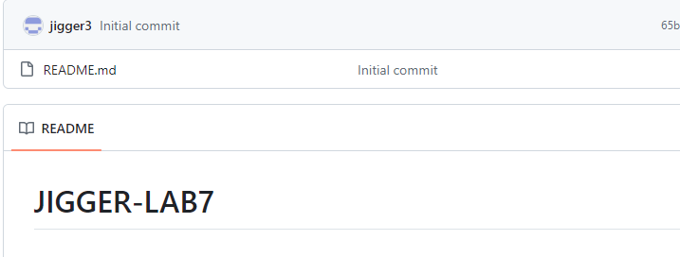

* NEW REPO NAMED LAB 7.

1. **Add a file named ‘List of households items’. Add at-least five (5) items.**

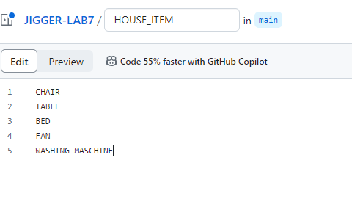

* ADD NEW FILE LIST OF HOUSEHOLD ITEM.

1. **Create a new branch ‘1 st branch’ from main.**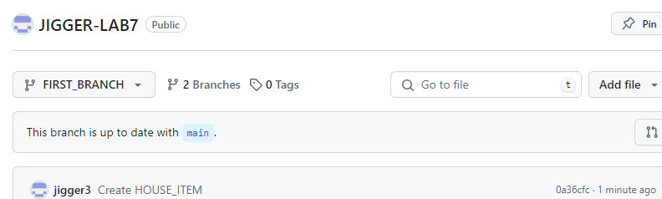

* CREATE FIRST BRANCH.

1. **Create a new branch ‘2nd branch’ from main.**

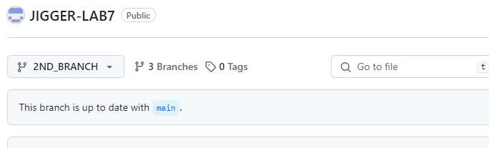

* CREATE 2ND BRANCH.

1. **Go to 1 st _branch and add an item and row number 10.**

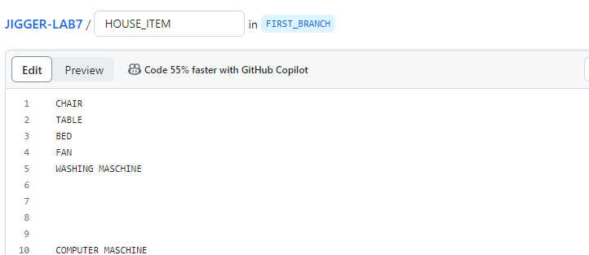

* ADD NEW ITEM IN 1ST BRANCH IN LINE 10.

1. **Merge this PULL request to main.**

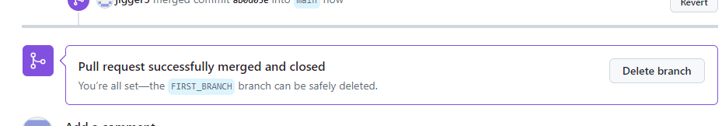

* MERGE THE 1ST BRANCH INTO MAIN AND CREATE PULL REQUEST.

1. **Go to 2 nd _branch and add an item and row number 10.**

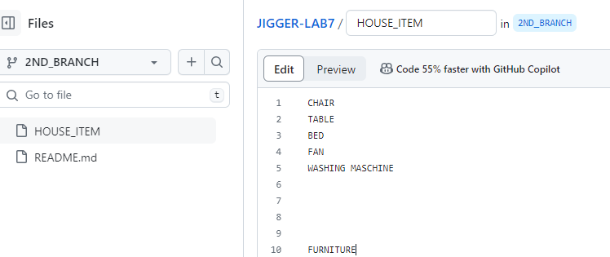

* ADD NEW ITEM IN LINE 10 IN 2ND BRANCH.

**8. Merge this PULL request to main. Do you get a conflicting issue? If so, resolve it, then**

**finally merge your 2 nd _branch to main. Attach the network graph.**

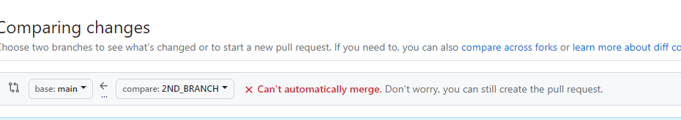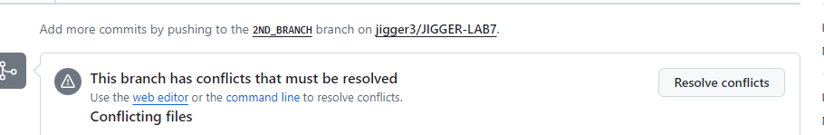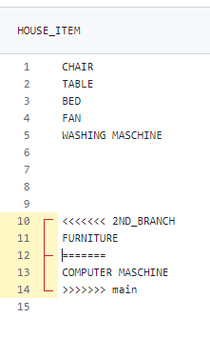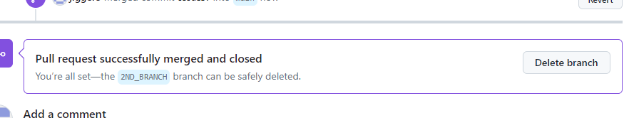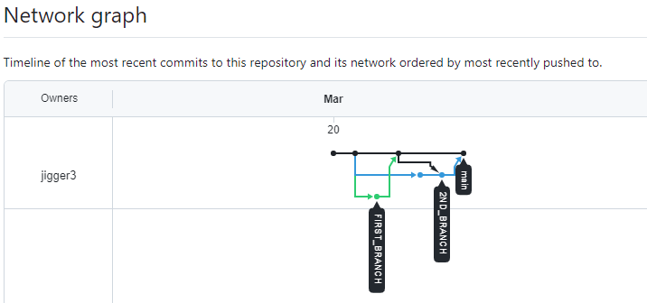

* ATTACH NETWORK GRAPH AFTER RESOLVE THE ISSUE.

**9. Open a new issue by going to the ‘Issues’ tab. DO NOT ACCEPT/MERGE THE ISSUE**

**YET.**

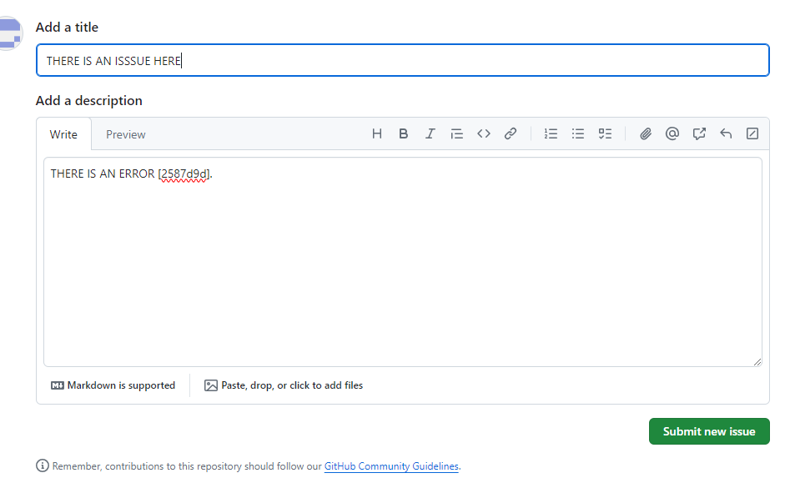

* NEW ISSUE OPEN WITH ISSSUE TAB.

**10. Now, use the commit/hash number of Question 7, and resolve the issue you opened in Question 9 by referencing to this hash.**

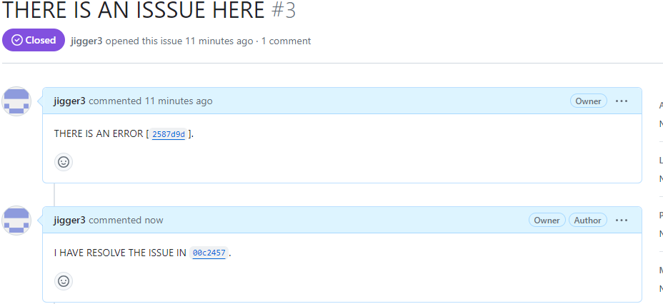

* OPEN ISSUE BY REFERENCE QUESTION 7 BY 9.

**11. Now, go to the change you made in hackeruser240/SCM repo (the PULL Request you**

**submitted in previous lab).**

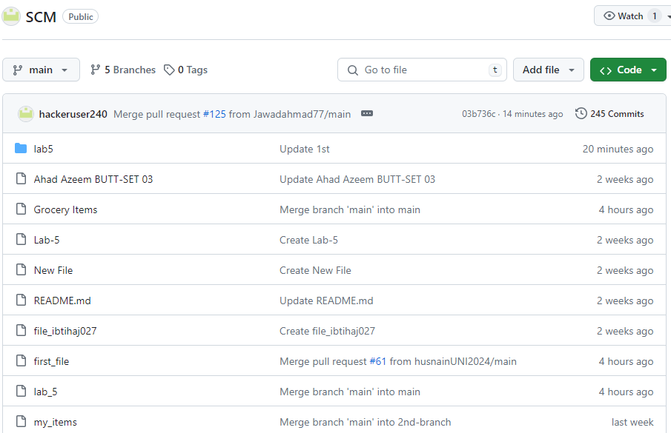

* GO TO CHANGE IN PREVIOUS LAB.

**12. Go to ‘Pull Request’ tab and locate the ‘Closed’ tab. Here, find your PULL request. Find the ‘PULL Request’ number and the hash of the (or any) commit (both).**

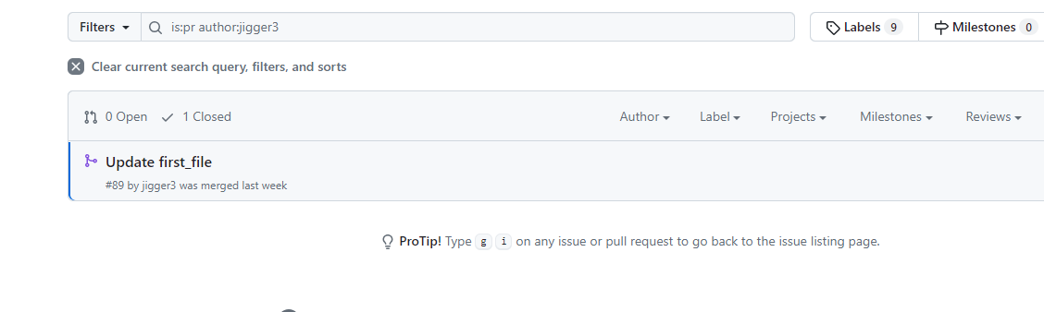

**13. Using the ‘issue’ tab, open a new issue of your commit (i.e. Step 11).**

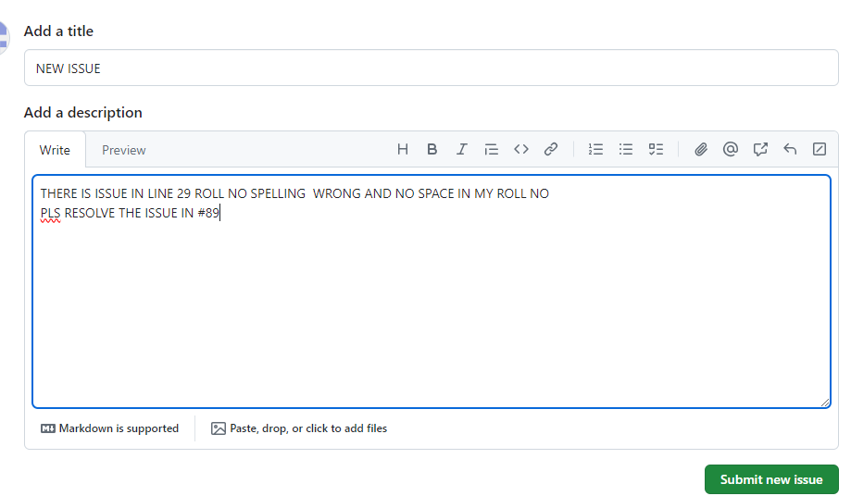

* OPEN ISSUE BY ISSUE TAB

**14. Now, give your issue a Title and add the comments you suggest to be changed. Using**

**both the PULL request number (of your PULL request) and the commit i.e. hash number,**

**suggest the changes as comments.**



**15. Finally, submit your Issue.**

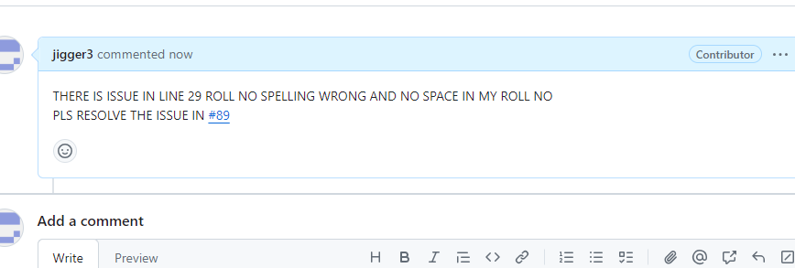

* SUBMITT ISSUE.

**16. Now, go to Pull Request #30 of hackeruser240/SCM and find how many commits have been in this Issue?**

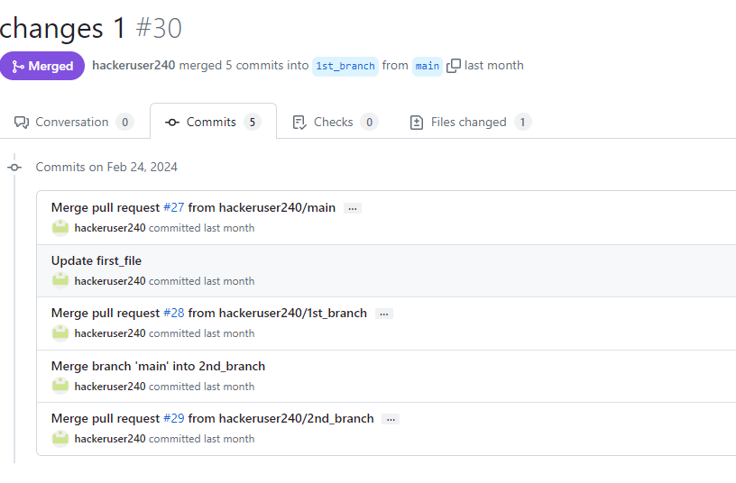

**17. Open a new issue by pointing out any issue of the commit hashes present in #30.**

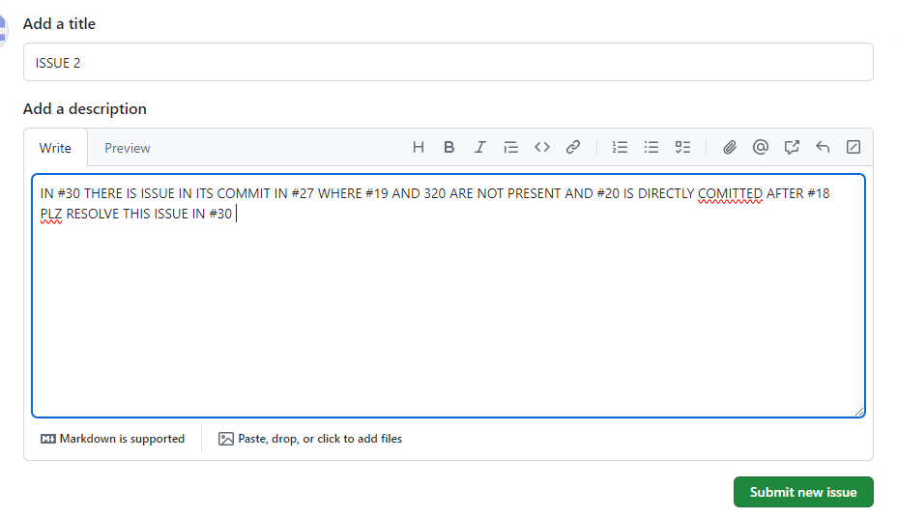

**18. Submit your Issue.**

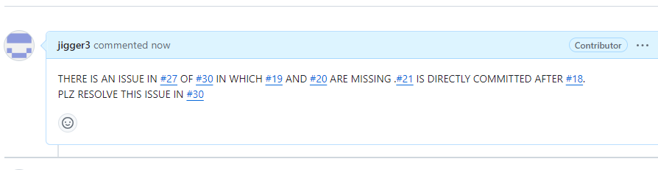

**GENERALIZED LAB RUBRICS**

|  |  |  |  |  |  |  |  |  |
| --- | --- | --- | --- | --- | --- | --- | --- | --- |
| **Domain** | **Component with Taxonomy** | **Above Expectation (4)** | **Meeting Expectation (3)** | **Approaching Expectation (2)** | **Below Expectation (1)** | **Used** | **Weight / 100**  **(Optional)** | **Score (1–4)** |
| **Psychomotor** | **Building (**Hardware) | Is able to build a given setup neatly and timely using correct hardware components and / or can reorganize / adapt to new / special requirements | Is able to assemble a given setup using correct hardware components after minor revisions | Is only able to copy a given setup using correct hardware components | Is not able to assemble a given setup using correct hardware components | ☐ |  |  |
| **Cognitive** | **Recording Measurements** (Hardware / Software) | Is able to record accurate measurements all the time | Is able to record accurate measurements most of the time | Is only able to record accurate measurements on some occasions | Is unable to record accurate measurements | ☐ |  |  |
| **Investigation**  (Software) | Is able to formulate /develop theories in addition to evaluating /concluding correctly about investigation parameters by assessing data | Is able to evaluate /conclude correctly about investigation parameters by assessing data | Is partially able to evaluate  /conclude correctly about investigation parameters by assessing data | Is unable to comprehend investigation parameters | ☐ |  |  |
| **Design / Development of Solution** (Hardware / Software) | Is able to design / develop the solution of a given problem and add features to it | Is able to design / develop the solution of a given problem | Is able to partially design / develop the solution of a given problem | Is unable to partially design  / develop the solution of a given problem | ☐ |  |  |
| **Software Usage**  (Software) | Is adept in the use of software tool and can access advanced features | Is able to use the software tool effectively by accessing all the required features | Is able to use the software tool but cannot access all the required features | Is unable to use the software tool | ☐ |  |  |
| **Programming Language** (Software) | Is able to efficiently complete a given task using advanced programming language constructs / methods / commands and/or add features to the original task | Is able to complete a given task using required programming language constructs / methods / commands | Is able to partially complete a given task | Is unable to partially complete a given task | ☐ |  |  |

**Name: Muhammad Khubaib**

**Roll no: 23st017**

**Department : Software Engineering Technology**

**LAB8**

**GitHub Issues, Commits & Pull Requests**

**1. Fork the hackeruser240/SCM repo.**

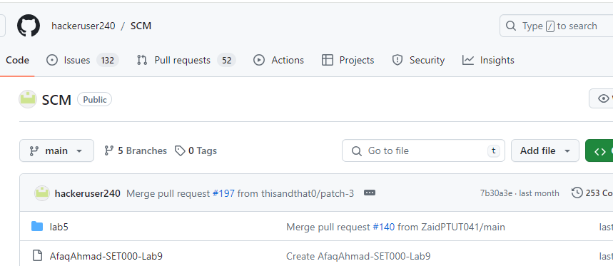

I have forked *hackeruser240/SCM* repo as required.

**2. Create a new file with your name as the name of the file.**

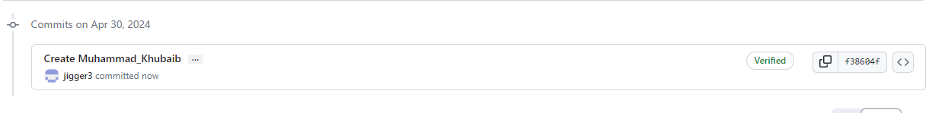

In the forked repo I have created a NEW file named as my name **“Muhammad Khubiab”** and added my roll no., department and name of subjects.

**4. Merge the file to the hackeruser240/SCM by a PULL request.**

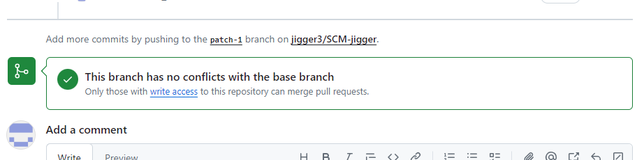

**5. Open a previous closed pull request. You can use your own pull request you generated before. In that pull request, locate the ‘Files Changed’ tab.**

**6. Add a comment on the line you suggest a change by pointing at the start of the line and pressing the ‘+’ sign. Click on ‘Add single comment’ and comment your suggestion.**

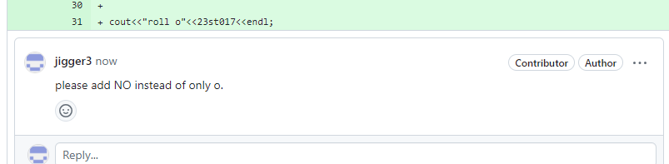

Now I have opened my previously closed pull request and I have commented a suggestion to add department name as well.

**7. Click on the three dots at the top right of the comment and ‘Reference this in a new issue’ Note that up till this point, you found an issue in an old pull request and mentioned it to the admin of the repo using a pull request.**

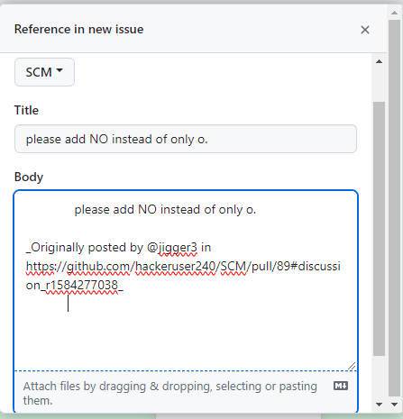

**8. Now, go to the Issues tab to make sure you have submitted your issue and it is properly mentioning the suggestion you pointed out and also, it is mentioning the correct ID number of your Pull request.**

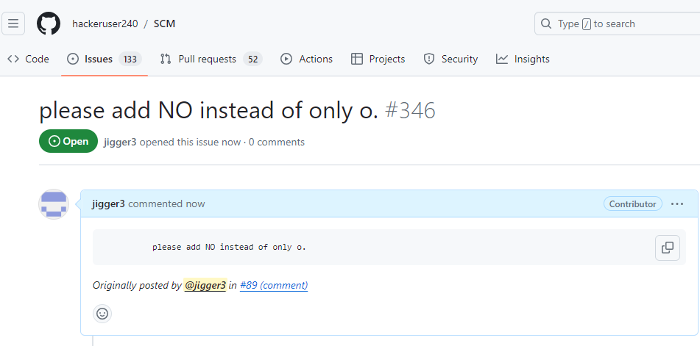

**9. Go back to your Pull request and make/edit the change that you suggested previously.**

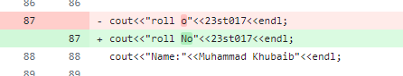

**10. Submit this change to the admin through a Pull request.**

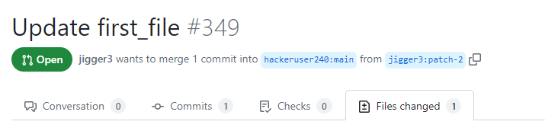

**11. Go to the issue tab and open the issue you submitted. In the timeline, mention the ID and hash number of the Pull request you submitted in Step 10.**

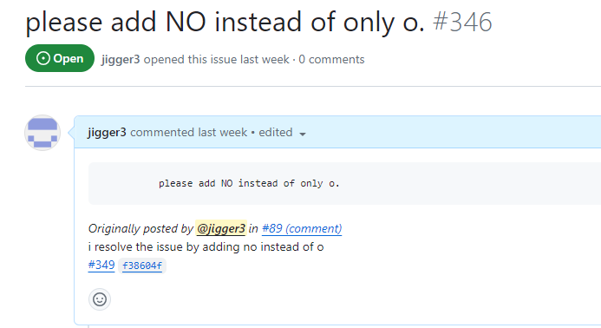

**Part-II: Using existing code to find and submit an issue**

**12. In the home section of hackeruser240/SCM, locate your pull request (that you sent in previous labs and which was merged) in the file.**

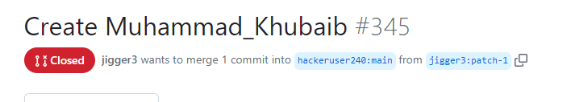

**13. Edit your file and add a comment by putting your mouse on the line number and clicking the three dots “…”, then ‘Referencing in a new issue’**

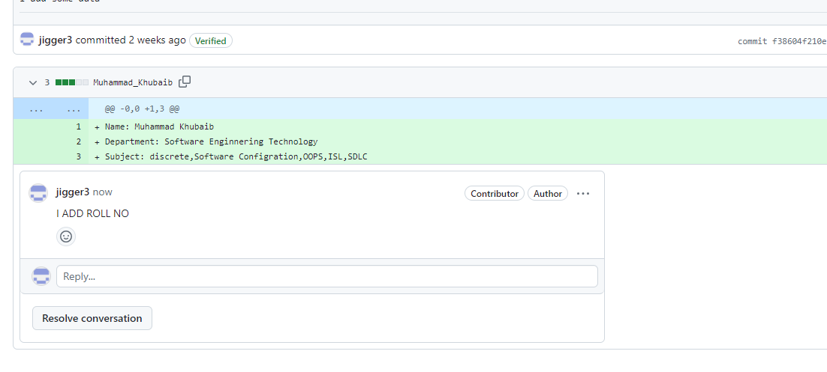

**14. Once you commit your changes, submit a pull request to merge your change Note that up till this point, you found an issue in a line of code and mentioned it to the admin of the repo using a pull request.**

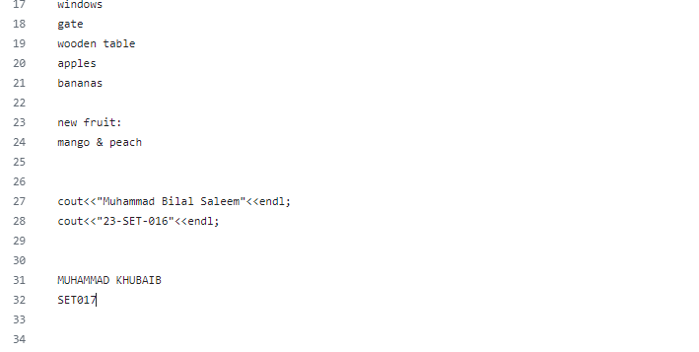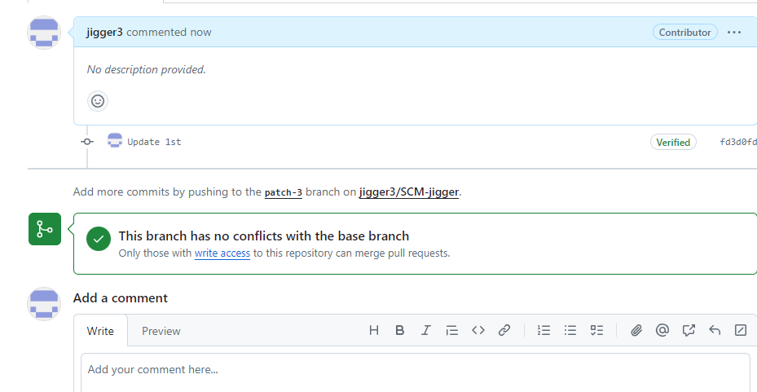

**15. Now, in a separate pull request, make your changes, and submit a new Pull request. Note that in Step 14, you pointed out only an issue in the existing code. YOU PROPOSED THE SOLUTION IN STEP 15**

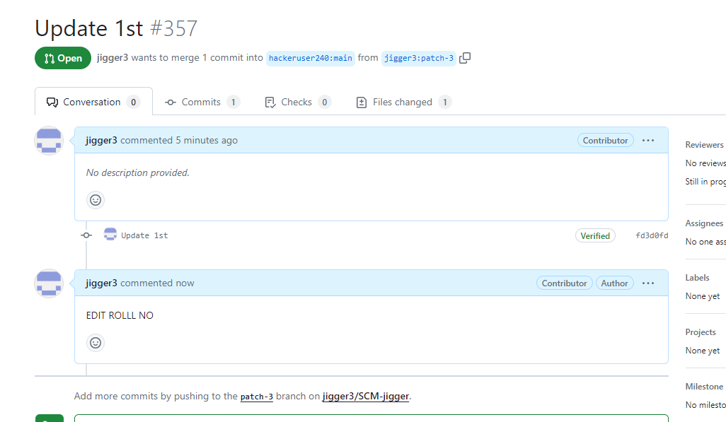

**16. Go to the issue you created in Step 14 and add the comment indicating the ID of the pull request you proposed in Step 15.**

**17. Finally save your comment and submit your issue**

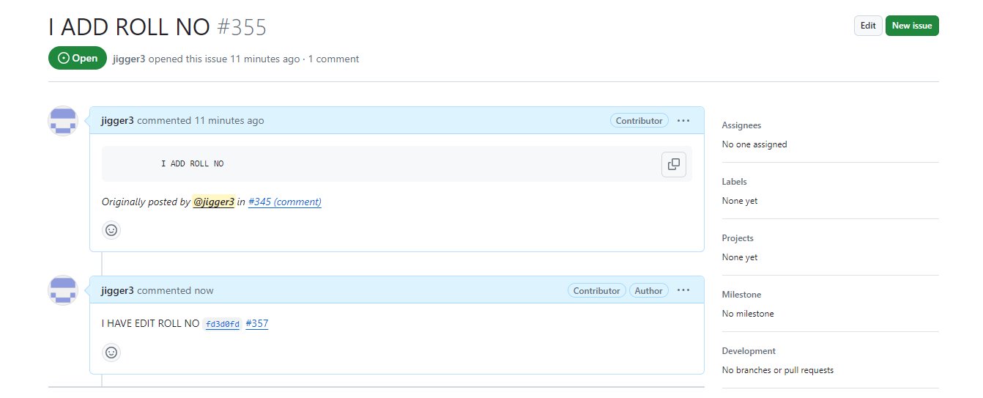

**GENERALIZED LAB RUBRICS**

|  |  |  |  |  |  |  |  |  |
| --- | --- | --- | --- | --- | --- | --- | --- | --- |
| **Domain** | **Component with Taxonomy** | **Above Expectation (4)** | **Meeting Expectation (3)** | **Approaching Expectation (2)** | **Below Expectation (1)** | **Used** | **Weight / 100**  **(Optional)** | **Score (1–4)** |
| **Psychomotor** | **Building (**Hardware) | Is able to build a given setup neatly and timely using correct hardware components and / or can reorganize / adapt to new / special requirements | Is able to assemble a given setup using correct hardware components after minor revisions | Is only able to copy a given setup using correct hardware components | Is not able to assemble a given setup using correct hardware components | ☐ |  |  |
| **Cognitive** | **Recording Measurements** (Hardware / Software) | Is able to record accurate measurements all the time | Is able to record accurate measurements most of the time | Is only able to record accurate measurements on some occasions | Is unable to record accurate measurements | ☐ |  |  |
| **Investigation**  (Software) | Is able to formulate /develop theories in addition to evaluating /concluding correctly about investigation parameters by assessing data | Is able to evaluate /conclude correctly about investigation parameters by assessing data | Is partially able to evaluate  /conclude correctly about investigation parameters by assessing data | Is unable to comprehend investigation parameters | ☐ |  |  |
| **Design / Development of Solution** (Hardware / Software) | Is able to design / develop the solution of a given problem and add features to it | Is able to design / develop the solution of a given problem | Is able to partially design / develop the solution of a given problem | Is unable to partially design  / develop the solution of a given problem | ☐ |  |  |
| **Software Usage**  (Software) | Is adept in the use of software tool and can access advanced features | Is able to use the software tool effectively by accessing all the required features | Is able to use the software tool but cannot access all the required features | Is unable to use the software tool | ☐ |  |  |
| **Programming Language** (Software) | Is able to efficiently complete a given task using advanced programming language constructs / methods / commands and/or add features to the original task | Is able to complete a given task using required programming language constructs / methods / commands | Is able to partially complete a given task | Is unable to partially complete a given task | ☐ |  |  |

**NAME: MUHAMMAD KHUBAIB**

**ROLLLNO: 23ST017**

**DEPARTMENT: SOFTWARE ENGINEERING TECHNOLOGY**

**LAB9**

**BASIC COMMAND OF GIT AS WELL AS WINDOW BASED CLI**

1. **Download and install Git from https://git-scm.com/downloads on your computer.**

* Install the git.

1. **Search for “Git Bash” and open it.**

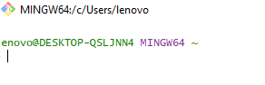

* Open Git Bash.

1. **Change the Git Bash theme to ‘kohlrausch’ setting.**

* Change the git bash theme.

1. **Find out the current working directory by executing the ‘pwd’ command.**

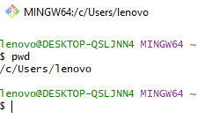

* Using pwd command to check location.

1. **Change your current directory from C drive to D drive using the cd command.**

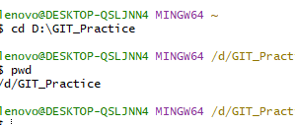

* Using cd command to change file location.

1. **Create a new repository by executing git init ‘you_repo_name’ command. Remove the above commas and write your repo name. Your command should look like this: git init afaq_ahmad.**

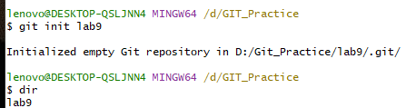

* Create new repository.

1. **Go to file explorer GUI and create a new text file in your repo. In that file, add your name, roll number and department in three separate lines.**

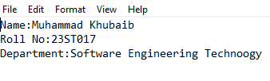

* Add data in new file.

1. **Go back to Git and display the contents of the current location using dir. It should display the file you created in GUI.**



* Using dir command to check file divectory.

1. **Now, view the status of your file by executing git status. You should see “No commits yet”. You should see your text file (you created in Step 7) in the “Untracked files” section.**

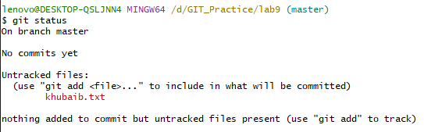

* Using git status command to check the status of file.

1. **Now, you will add your file to git stage using the git add command. Your command should look like:**



* Using git add command for stag.

1. **Now view the status of your file by git status. You should see your text file in the ‘Changes to be committed’ section.**

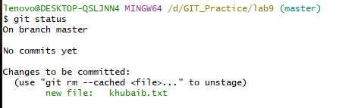

* Using git status command to check status after stag.

1. **Now, commit your file by using the git commit command. You will also comment on your commit as you do in GitHub as well. You will use the ‘-m’ option. Look at the command below: git commit -m ‘this is my first commit using git!’.**

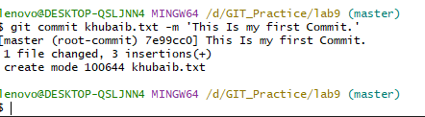

* Using git commit command to commit file after stag.

1. **Go back to GUI and add a new file with your roll number as the name in the location of your git repo. In that file, also add the list of the subjects and their finals grades. If you do not have grades, you can enter their total numbers. You can use sample values for this.**

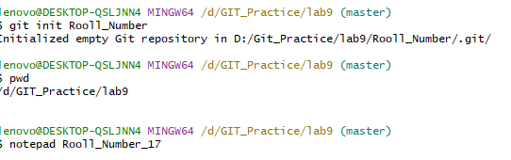

* To Create new file named roll number using it init command.

1. **Go back to CLI and list the contents of the directory of your repo. You should see your new file you created.**



* Using dr command to check the directory of repo.

1. **Now, add this new file to git stage using git add.**



* Usind git command for stag.

1. **Do git status and check the status of your file. Your new file should be in the ‘Untracked files’ category.**

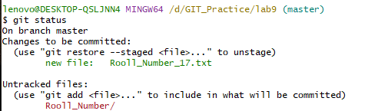

* Using git status command to check status after stage of file.

1. **Add your new file (file created in Step 12) to commit using git commit and add a message as well Save the repo you are working on. You will be using it in the next upcoming labs.**

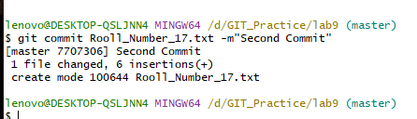

* Using git commit command to commit.

**GENERALIZED LAB RUBRICS**

|  |  |  |  |  |  |  |  |  |
| --- | --- | --- | --- | --- | --- | --- | --- | --- |
| **Domain** | **Component with Taxonomy** | **Above Expectation (4)** | **Meeting Expectation (3)** | **Approaching Expectation (2)** | **Below Expectation (1)** | **Used** | **Weight / 100**  **(Optional)** | **Score (1–4)** |
| **Psychomotor** | **Building (**Hardware) | Is able to build a given setup neatly and timely using correct hardware components and / or can reorganize / adapt to new / special requirements | Is able to assemble a given setup using correct hardware components after minor revisions | Is only able to copy a given setup using correct hardware components | Is not able to assemble a given setup using correct hardware components | ☐ |  |  |
| **Cognitive** | **Recording Measurements** (Hardware / Software) | Is able to record accurate measurements all the time | Is able to record accurate measurements most of the time | Is only able to record accurate measurements on some occasions | Is unable to record accurate measurements | ☐ |  |  |
| **Investigation**  (Software) | Is able to formulate /develop theories in addition to evaluating /concluding correctly about investigation parameters by assessing data | Is able to evaluate /conclude correctly about investigation parameters by assessing data | Is partially able to evaluate  /conclude correctly about investigation parameters by assessing data | Is unable to comprehend investigation parameters | ☐ |  |  |
| **Design / Development of Solution** (Hardware / Software) | Is able to design / develop the solution of a given problem and add features to it | Is able to design / develop the solution of a given problem | Is able to partially design / develop the solution of a given problem | Is unable to partially design  / develop the solution of a given problem | ☐ |  |  |
| **Software Usage**  (Software) | Is adept in the use of software tool and can access advanced features | Is able to use the software tool effectively by accessing all the required features | Is able to use the software tool but cannot access all the required features | Is unable to use the software tool | ☐ |  |  |
| **Programming Language** (Software) | Is able to efficiently complete a given task using advanced programming language constructs / methods / commands and/or add features to the original task | Is able to complete a given task using required programming language constructs / methods / commands | Is able to partially complete a given task | Is unable to partially complete a given task | ☐ |  |  |

**Name: Muhammad Khubaib**

**Roll No: 23ST017**

**Department: Software Engineering Technology**

**LAB_10**

**Part-I: Creating branches**:

1. **Go to your master branch (you are already there) and create a new file. Name it ‘List_of_Subjects’. You will use CLI for this step.**

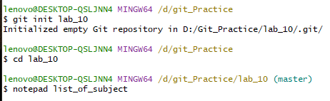

* Create a new file list-of-subject.

1. **Open your file and just add your name, save it and close it.**

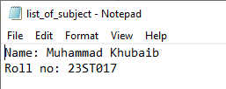

* Open the new file with notepad command and write name and roll no.

1. **Add your file to stage and then commit using git add and git commit**.

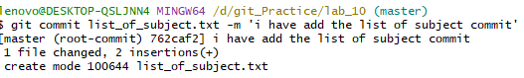

* Using git add and git commit command to commit the file list-of-subject.

1. **Apply git log.**

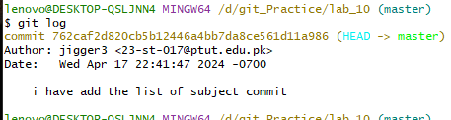

* Using git log command to check history.

1. **In your repo create a new branch using git branch command. You can use your own branch name git branch 1st_branch**.



* Create first branch with the command git branch.

1. **View the number of branches you have using git branch. The current branch will be highlighted a green color and will have a ‘*’ symbol next to it.**

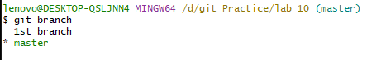

* Using git branch command only check the branch location.

1. **Create and move to a branch ‘fsc_subjects’ using the following commands:**

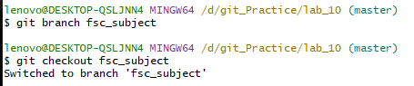

* Create a branch with the command git branch and switch to branch with command git checkout.

1. **In this branch, open List_of_Subjects (using the notepad command) and add your fsc_subjects. Save your file and close it.**

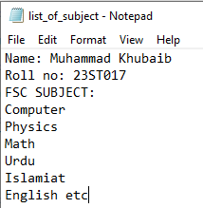

* Using notepad command add the fsc subject name in list of subject.

1. **Go to Git and add your file to the stage, then commit it.**

* **git add list_of_subjects.txt**
* **git commit -m ‘add your description’**

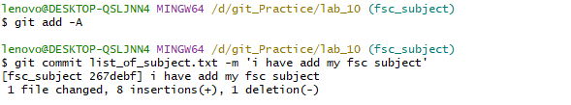

* using git add and git commit command to commit the fsc-branch.

1. **Apply git log.**

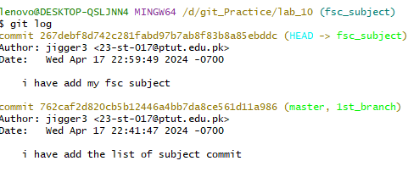

* Using git log command to check history.

1. **Create a new branch named ‘semester1’. Shift to this branch and add your subjects of 1st semester in List_of_Subjects. Save and close the file.**

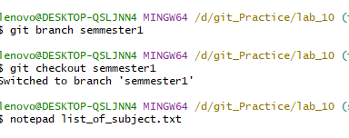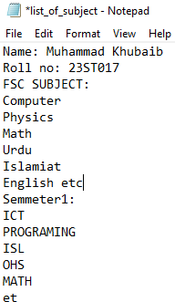

* Create a new branch semester1 and by using command git branch and switch to it by using git checkout command.
* Using notepad command add semmeste1 subject name.

1. **Add this file to stage and then commit it to the semester1 branch.**

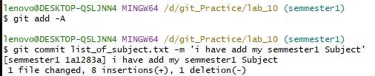

* using git add and git commit command to commit the semmeste1.

1. **Do git log.**

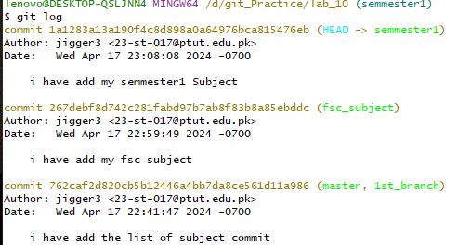

* Using git log command to check history.

1. **Create a new branch name ‘semester2’ and add the subjects of Semester 2 in this file of the branch.**

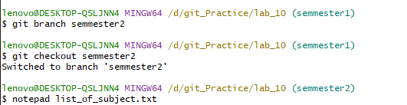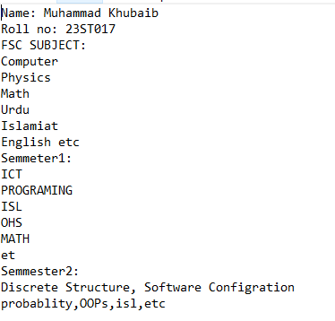

* Create a new branch semester2 and by using command git branch and switch to it by using git checkout command
* Using notepad command add semmeste2 subject name.

1. **(Repeat), add and then commit the file with description to the semester2 branch.**

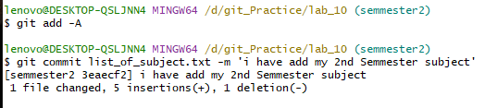

* using git add and git commit command to commit the semmeste2.

1. **Do git log.**

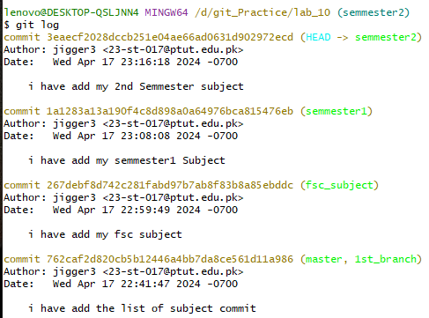

* Using git log command to check history.

**Part-II: Merging branches:**

1. **Go to the semester1 branch. Merge the semester2 branch in it. Note: This will cause the 2nd semester subjects to appear in the List_of_Subjects file the semester1 branch has. git merge s2.**

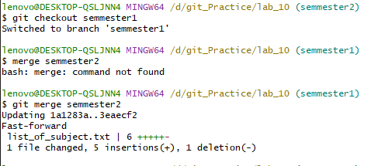

* Using git checkout command switch to branch semmeste1 then using git merge command and merge the semester2 branch in semester1 branch.

1. **Merge semester1 in fsc_subjects.**

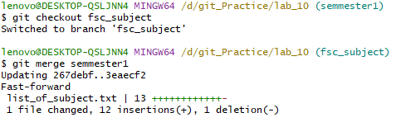

* Using git checkout command switch to branch fsc-subject then using git merge command and merge the semester1 branch in fsc-branch branch.

1. **Now go to the master branch and merge the fsc_subjects**.

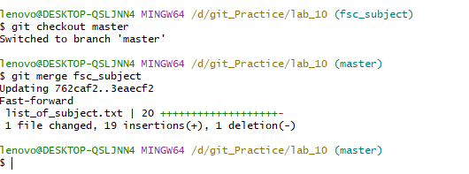

* Using git checkout command switch to branch master then using git merge command and merge the fsc-branch branch in master branch.

1. **Check the status of all the branches you have.**

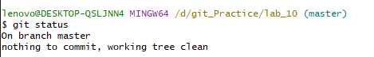

* Using git status command to check status.

1. **To check the history of the changes/commits made, execute the command git log.**

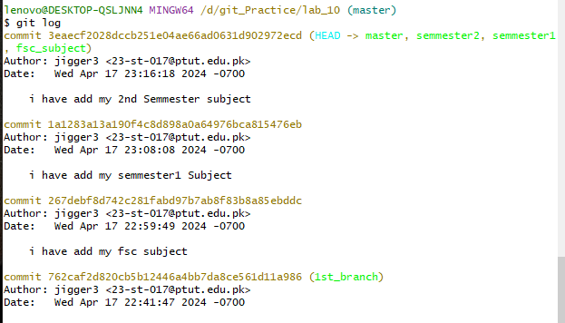

* Using git log command to check history.

**GENERALIZED LAB RUBRICS**

|  |  |  |  |  |  |  |  |  |
| --- | --- | --- | --- | --- | --- | --- | --- | --- |
| **Domain** | **Component with Taxonomy** | **Above Expectation (4)** | **Meeting Expectation (3)** | **Approaching Expectation (2)** | **Below Expectation (1)** | **Used** | **Weight / 100**  **(Optional)** | **Score (1–4)** |
| **Psychomotor** | **Building (**Hardware) | Is able to build a given setup neatly and timely using correct hardware components and / or can reorganize / adapt to new / special requirements | Is able to assemble a given setup using correct hardware components after minor revisions | Is only able to copy a given setup using correct hardware components | Is not able to assemble a given setup using correct hardware components | ☐ |  |  |
| **Cognitive** | **Recording Measurements** (Hardware / Software) | Is able to record accurate measurements all the time | Is able to record accurate measurements most of the time | Is only able to record accurate measurements on some occasions | Is unable to record accurate measurements | ☐ |  |  |
| **Investigation**  (Software) | Is able to formulate /develop theories in addition to evaluating /concluding correctly about investigation parameters by assessing data | Is able to evaluate /conclude correctly about investigation parameters by assessing data | Is partially able to evaluate  /conclude correctly about investigation parameters by assessing data | Is unable to comprehend investigation parameters | ☐ |  |  |
| **Design / Development of Solution** (Hardware / Software) | Is able to design / develop the solution of a given problem and add features to it | Is able to design / develop the solution of a given problem | Is able to partially design / develop the solution of a given problem | Is unable to partially design  / develop the solution of a given problem | ☐ |  |  |
| **Software Usage**  (Software) | Is adept in the use of software tool and can access advanced features | Is able to use the software tool effectively by accessing all the required features | Is able to use the software tool but cannot access all the required features | Is unable to use the software tool | ☐ |  |  |
| **Programming Language** (Software) | Is able to efficiently complete a given task using advanced programming language constructs / methods / commands and/or add features to the original task | Is able to complete a given task using required programming language constructs / methods / commands | Is able to partially complete a given task | Is unable to partially complete a given task | ☐ |  |  |

**NAME: MUHAMMAD KHUBAIB**

**ROLL NO: 23ST017**

**DEPARTMENT: SOFTWARE ENGINEERING TECHNOLOGY**

**LAB11**

**Commands of Git and integrate it with Git hub**

1. **Open your repo in Git bash by using the cd command (if you are currently in C drive).**

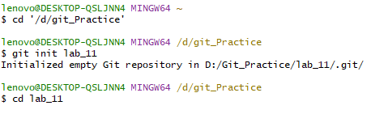

1. **Display your contents using dir.**

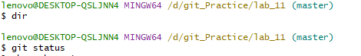

1. **Display your git status for your current master branch.**

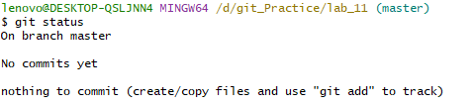

**4. Create your new repo on GitHub with the exact same name as your local repo. Do NOT**

**add the ‘Read Me’ file.**

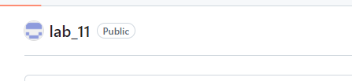

Part-I: Pushing your code to a remote Repo

**5. Git needs to know which remote repo to upload to. For this, execute:**

**git remote add origin <your link>**



**6. Create an repo, add a file, stage it and then commit it.**

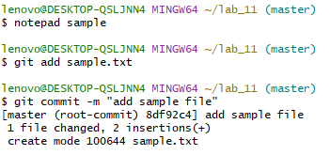

7. **To upload your code from your computer (local repo) to GitHub (remote repo), you need to push your code: git push -u origin master.**

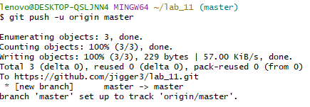

**8. From GitHub, attach the network graph.**

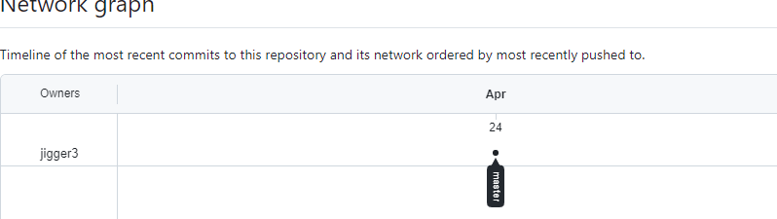

**Part-II: Making changes in GitHub**

**9. In GitHub, go any file in the main branch, make a change and commit it (all on GitHub).**

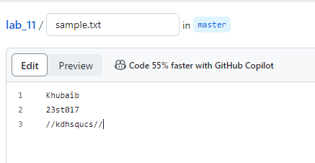

Part-III: Pulling the code from the GitHub repo using git diff and git merge

**10. Find out the changes/history made in the remote repo (if any) using: git fetch origin.**

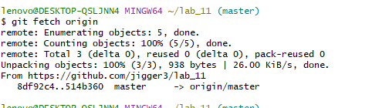

**11. Check the status of your local repo.**

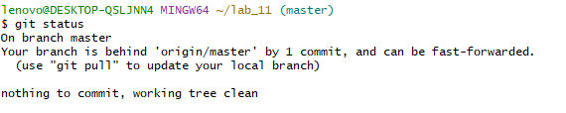

12**. Is your branch behind any the branch of ‘origin/master’? Write your answer.**

Yes

13. **Find out the difference between master (local repo) and origin/master (remote repo) using: git diff origin/master.**

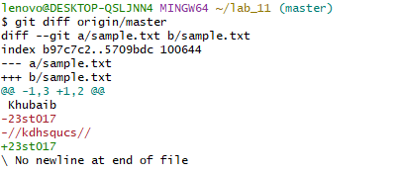

**From the display given, write what is the difference?**

Ans=I add a new line in sample.txt in through git hub.

**14. Do git log.**

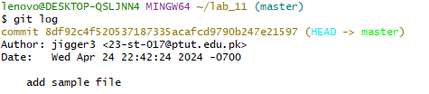

**15. To make sure you are up-to-date, you download and merge the changes (the changes you made in Step 12 & 13) in your local repo using: git merge origin/master.**

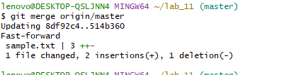

**16. Check the status to make sure that the changes made in in Step 12 & 13 are reflected/copied/download in your local repo**

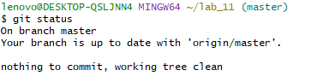

**Part-IV: Uploading a different branch to GitHub**

**17. In your Git repo, create a new branch from master and make some changes to the file.**

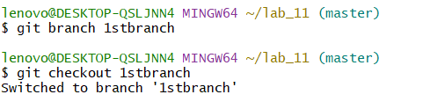

**18. Stage and commit your changes.**

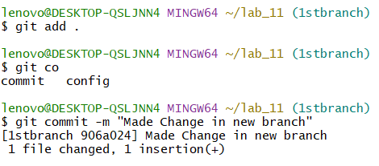

**19. Upload this branch using push command.**

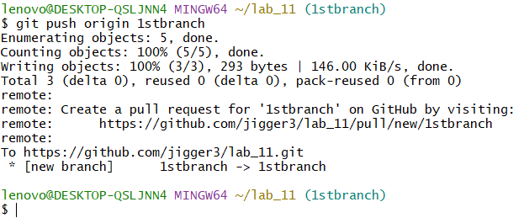

**20. On GitHub, verify that this branch has been uploaded.**

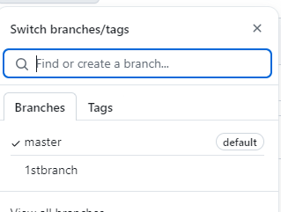

**21. On GitHub, make any change to the file on this current (new) branch.**

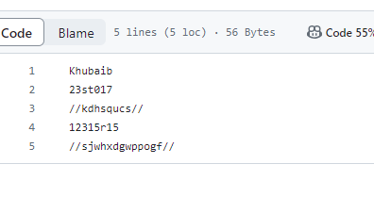

**22. Go back to Git, check out what message it given to you using git fetch origin.**

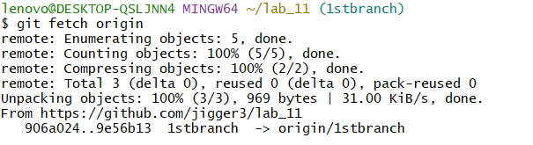

**23. Also execute git diff origin/<your_new_branch_name> command.**

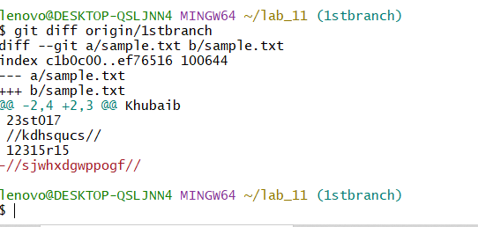

**24. To merge this change, you will use: git merge origin/<your_new_branch_name>.**

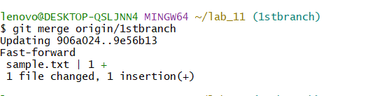

**GENERALIZED LAB RUBRICS**

|  |  |  |  |  |  |  |  |  |
| --- | --- | --- | --- | --- | --- | --- | --- | --- |
| **Domain** | **Component with Taxonomy** | **Above Expectation (4)** | **Meeting Expectation (3)** | **Approaching Expectation (2)** | **Below Expectation (1)** | **Used** | **Weight / 100**  **(Optional)** | **Score (1–4)** |
| **Psychomotor** | **Building (**Hardware) | Is able to build a given setup neatly and timely using correct hardware components and / or can reorganize / adapt to new / special requirements | Is able to assemble a given setup using correct hardware components after minor revisions | Is only able to copy a given setup using correct hardware components | Is not able to assemble a given setup using correct hardware components | ☐ |  |  |
| **Cognitive** | **Recording Measurements** (Hardware / Software) | Is able to record accurate measurements all the time | Is able to record accurate measurements most of the time | Is only able to record accurate measurements on some occasions | Is unable to record accurate measurements | ☐ |  |  |
| **Investigation**  (Software) | Is able to formulate /develop theories in addition to evaluating /concluding correctly about investigation parameters by assessing data | Is able to evaluate /conclude correctly about investigation parameters by assessing data | Is partially able to evaluate  /conclude correctly about investigation parameters by assessing data | Is unable to comprehend investigation parameters | ☐ |  |  |
| **Design / Development of Solution** (Hardware / Software) | Is able to design / develop the solution of a given problem and add features to it | Is able to design / develop the solution of a given problem | Is able to partially design / develop the solution of a given problem | Is unable to partially design  / develop the solution of a given problem | ☐ |  |  |
| **Software Usage**  (Software) | Is adept in the use of software tool and can access advanced features | Is able to use the software tool effectively by accessing all the required features | Is able to use the software tool but cannot access all the required features | Is unable to use the software tool | ☐ |  |  |
| **Programming Language** (Software) | Is able to efficiently complete a given task using advanced programming language constructs / methods / commands and/or add features to the original task | Is able to complete a given task using required programming language constructs / methods / commands | Is able to partially complete a given task | Is unable to partially complete a given task | ☐ |  |  |

**NAME: MUHAMMAD KHUBAIB**

**ROLL NO: 23ST017**

**DEPARTMENT: SOFTWARE ENGINNERING TECHNOLOGY**

**LAB12**

**Git: Pushing & Pulling of Local to Remote repo**

**Part-I:**

1. **Create ‘Calculator’ repo in GitHub.**

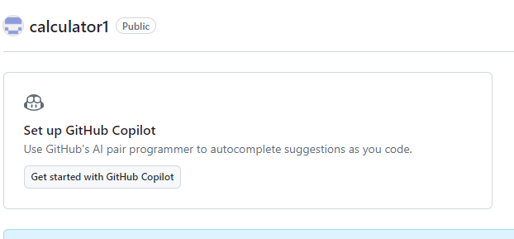

* Crate a repo name calculator

1. **On your computer, create a new repo in Git.**

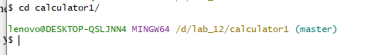

* Create repo on git same name.

1. **In GitHub, create a simple file and add your name and roll number and commit it to master branch.**

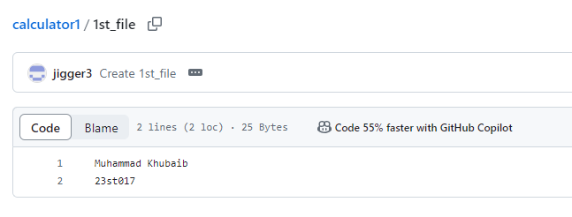

* Add roll no and name in 1st file and commit it to main branch.

**4. Back in Git, your need to copy these changes on your local repo. You will use git fetch for any change.**

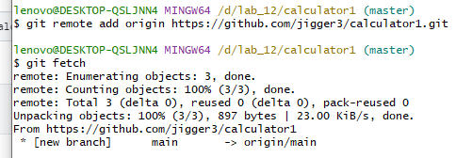

* Using git remote add origin branch to switch to remote repository in github.

**5. If you have any change, merge it to your local Git repo.**

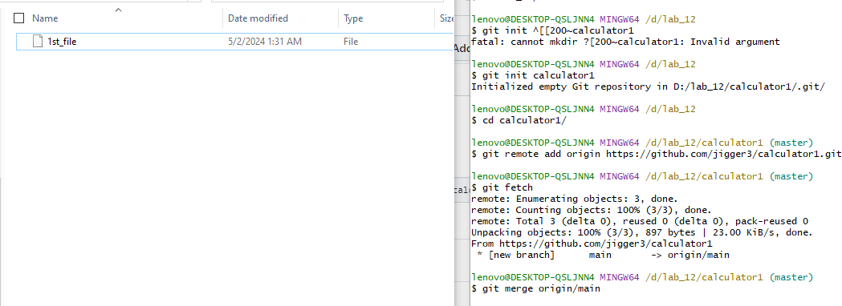

* Merge the first file in the main branch.

**Part-II: Creating ‘Addition’ branch**

**6. In Git, create a new branch ‘Addition’. Add a new line to add two numbers. Save the file.**

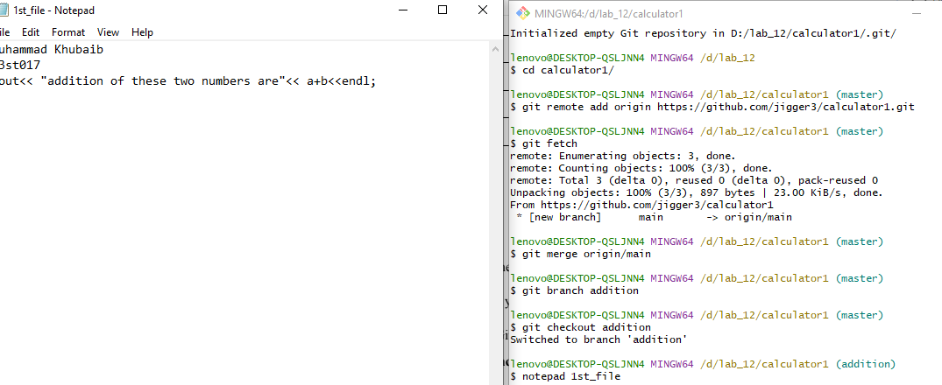

* Create a addition branch and using checkout command to switch addition branch.

**7. Stage the addition branch.**



* Stage the addition branch by using git add command.

**8. Commit it by adding a useful comment.**



* Commit the addition branch by using git commit after stage.

**9. Now push this branch to GitHub using: git push origin addition.**

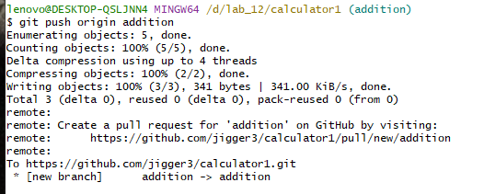

* Push to github addition branch by using git push origin command.

**10. In GitHub, verify that this branch has been uploaded and contains the necessary line of codes**.

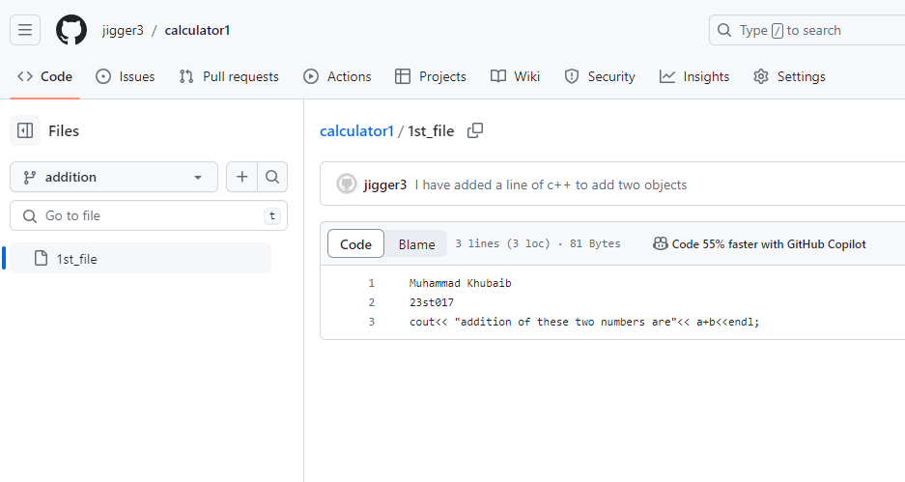

* In github.

**Part-III: Creating ‘Subtraction branch**

**11. Repeat the five steps (of Part-I) for ‘Subtraction’ branch.**

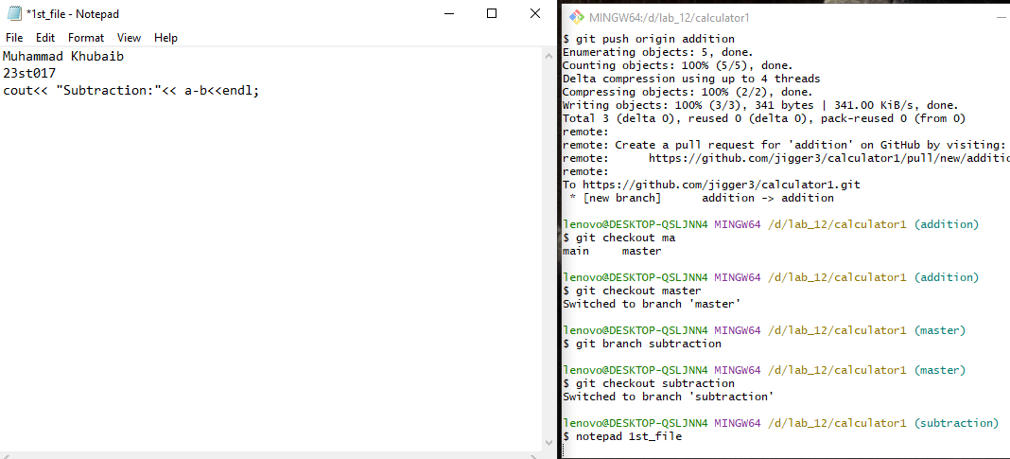

* Create a substraction branch and using checkout command to switch substraction branch.



* Stage the substraction branch by using git add command.

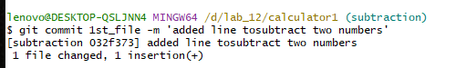

* Commit the substration branch by using git commit after stage.

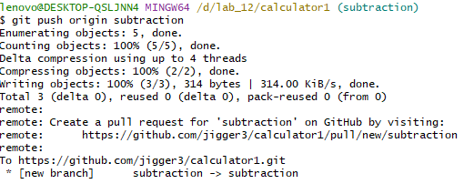

* Push to github substraction branch by using git push origin command.

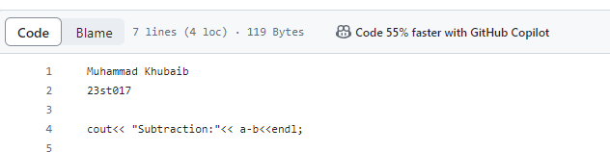

* In github.

**Part-IV: Creating ‘Multiplication’ branch**

**12. Repeat the five steps (of Part-I) for ‘Multiplication branch.**

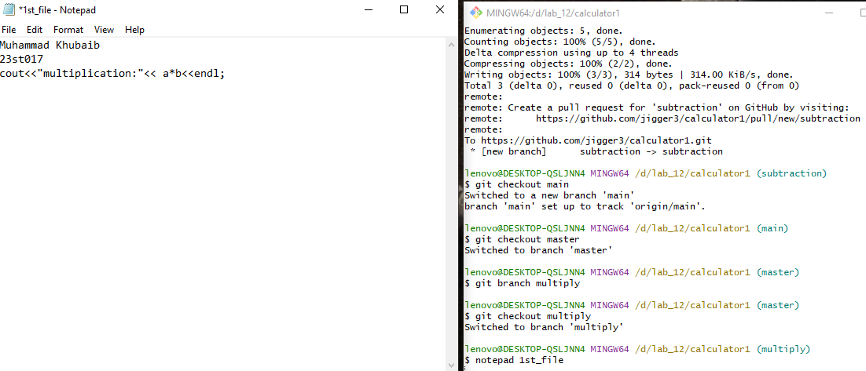

* Create a Multiplication branch and using checkout command to switch substraction branch.



* Stage the Multiplication branch by using git add command.

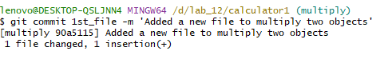

* Commit the Multiplication branch by using git commit after stage.

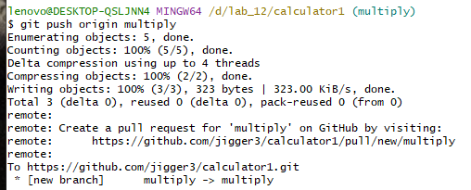

* Push to github Multiplication branch by using git push origin command.

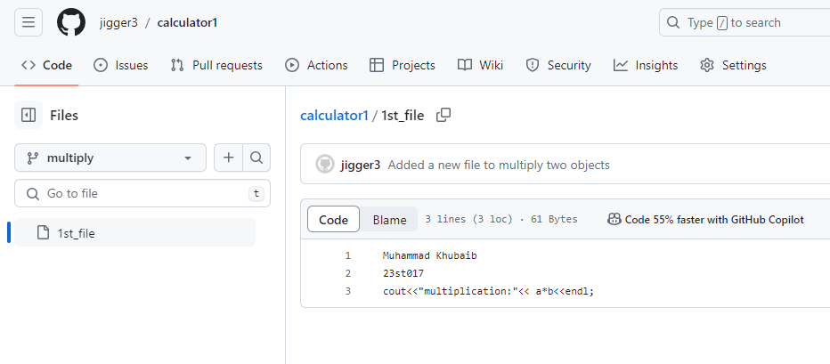

* In github.

**Part-V: Creating ‘Division branch**

**13. Repeat the five steps (of Part-I) for ‘Division branch.**

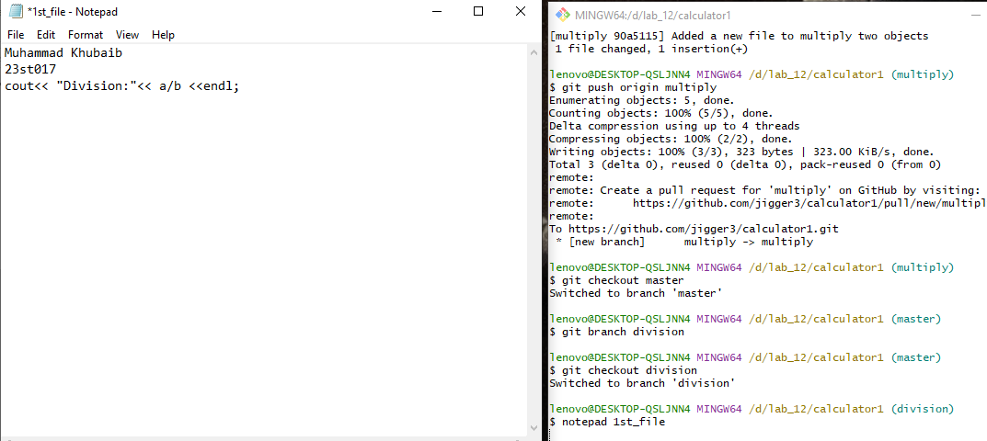

* Create a Division branch and using checkout command to switch substraction branch.

C:\Users\lenovo\AppData\Local\Microsoft\Windows\INetCache\Content.Word\s13 b.png

* Stage the Division branch by using git add command.

C:\Users\lenovo\AppData\Local\Microsoft\Windows\INetCache\Content.Word\s13c.png

* Commit the Division branch by using git commit after stage.

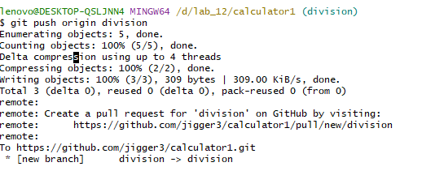

* Push to github Division branch by using git push origin command.

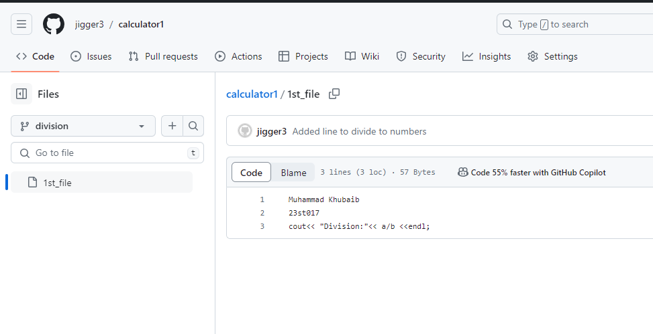

* In github.

Part-VI:

**14. Now on GitHub, you need to step-by-step merge the branches into one another.**

**You will create Pull Requests with proper commits. The sequence is: add ← sub ← mul ← div**

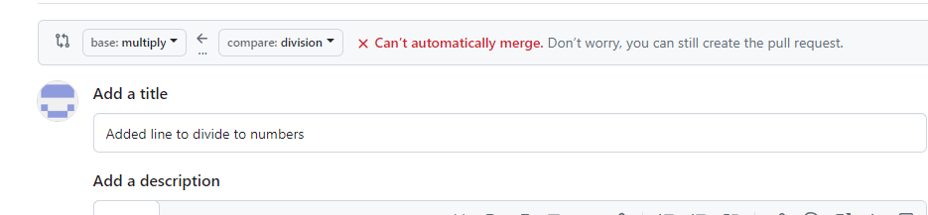

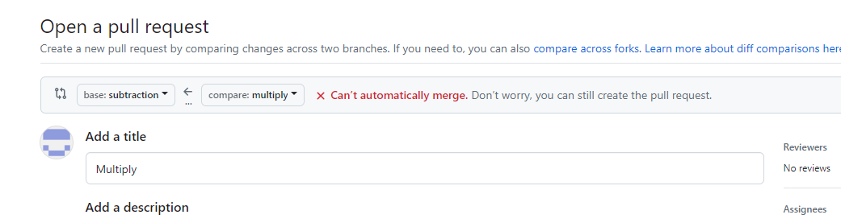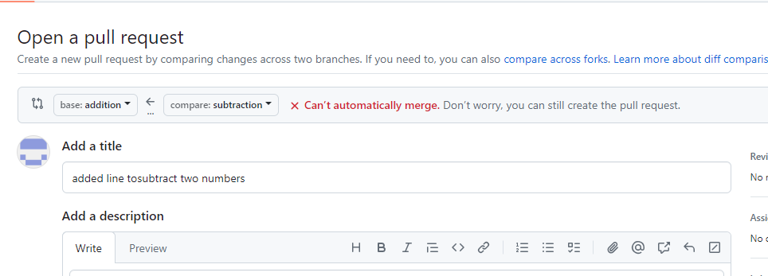

* Create a pull request according to this: add ← sub ← mul ← div and merge it to main.

15. Now you have updated your GitHub repo. To pull these changes from GitHub,

you will figure out which command works for and explain why: a. git fetch b. git pull

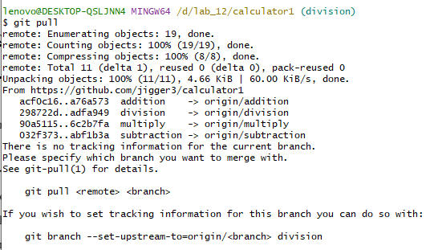

* Using git pull for updated repo.

**GENERALIZED LAB RUBRICS**

|  |  |  |  |  |  |  |  |  |
| --- | --- | --- | --- | --- | --- | --- | --- | --- |
| **Domain** | **Component with Taxonomy** | **Above Expectation (4)** | **Meeting Expectation (3)** | **Approaching Expectation (2)** | **Below Expectation (1)** | **Used** | **Weight / 100**  **(Optional)** | **Score (1–4)** |
| **Psychomotor** | **Building (**Hardware) | Is able to build a given setup neatly and timely using correct hardware components and / or can reorganize / adapt to new / special requirements | Is able to assemble a given setup using correct hardware components after minor revisions | Is only able to copy a given setup using correct hardware components | Is not able to assemble a given setup using correct hardware components | ☐ |  |  |
| **Cognitive** | **Recording Measurements** (Hardware / Software) | Is able to record accurate measurements all the time | Is able to record accurate measurements most of the time | Is only able to record accurate measurements on some occasions | Is unable to record accurate measurements | ☐ |  |  |
| **Investigation**  (Software) | Is able to formulate /develop theories in addition to evaluating /concluding correctly about investigation parameters by assessing data | Is able to evaluate /conclude correctly about investigation parameters by assessing data | Is partially able to evaluate  /conclude correctly about investigation parameters by assessing data | Is unable to comprehend investigation parameters | ☐ |  |  |
| **Design / Development of Solution** (Hardware / Software) | Is able to design / develop the solution of a given problem and add features to it | Is able to design / develop the solution of a given problem | Is able to partially design / develop the solution of a given problem | Is unable to partially design  / develop the solution of a given problem | ☐ |  |  |
| **Software Usage**  (Software) | Is adept in the use of software tool and can access advanced features | Is able to use the software tool effectively by accessing all the required features | Is able to use the software tool but cannot access all the required features | Is unable to use the software tool | ☐ |  |  |
| **Programming Language** (Software) | Is able to efficiently complete a given task using advanced programming language constructs / methods / commands and/or add features to the original task | Is able to complete a given task using required programming language constructs / methods / commands | Is able to partially complete a given task | Is unable to partially complete a given task | ☐ |  |  |

**NAME: MUHAMMAD KHUBAIB**

**ROLL NO: 23ST017**

**DEPARTMENT: SOFTWARE ENGINNERING TECHNOLOGY**

**LAB_13**

**GIT: PUSHING &PULLING OF LOCAL TO REMOTE REPO**

**1.Create an empty repo on GitHub. Add the README file.**

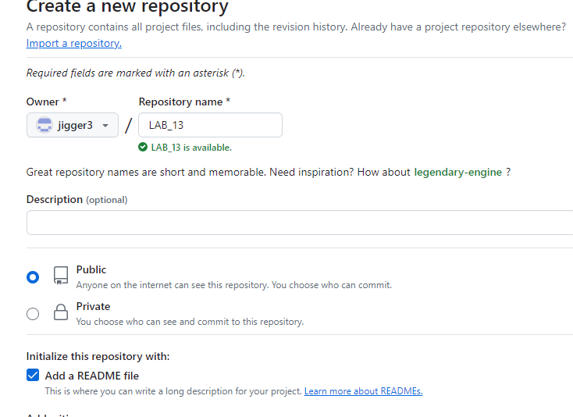

**2.To fork this repo in your local Git account, use the following command: git clone <url>**

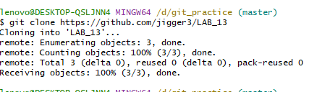

**3.Create a simple text file. Add a little introduction on yourself. Do NOT add your name and roll number.**



**4.Push this file from Git to GitHub. Make sure you have added origin in Git.**

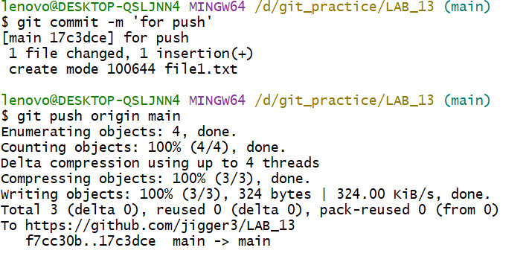

**5.In GitHub, verify that your file has been added.**

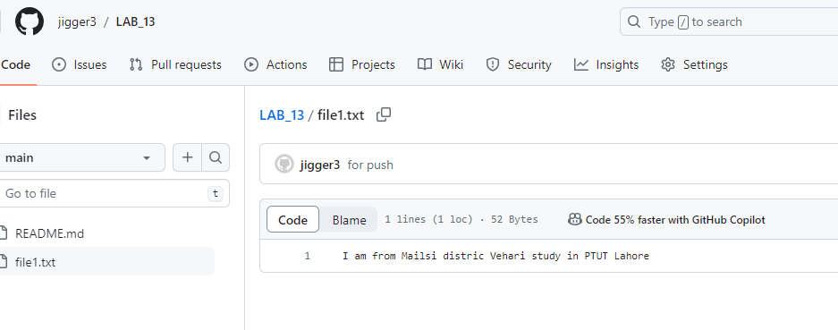

**6.In GitHub, add a new file file2 in master branch. In file2, add any description you like.**

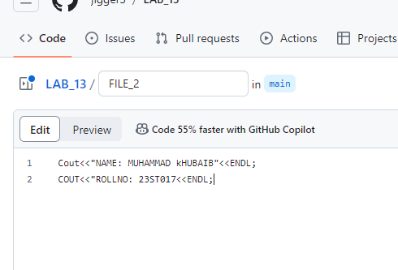

**7. GitHub: Create a new branch new_branch from master. In new_branch, create a new file file3. Add your hobbies.**

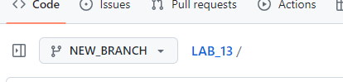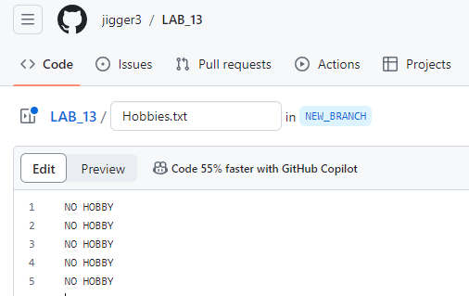

**Part-I: Using fetch & merge**

**8.Git: To see if the remote repo has any (that you do not have), use git fetch. What is the result?**

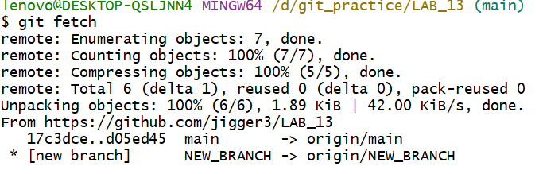

**9.You should be on master branch. Checkout the difference between the origin and git master using git diff.**

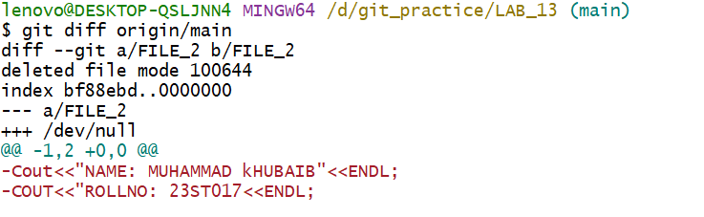

**10.Using fetch, you only downloaded those changes from GitHub. To apply those changes in your git repo, execute git merge.**

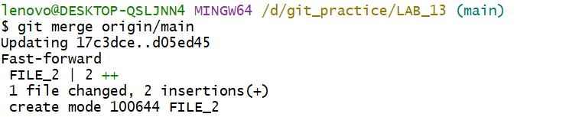

**11.Figure out the command (you already executed it in previous labs) to make sure that your git repo is up-to-date with your GitHub repo.**

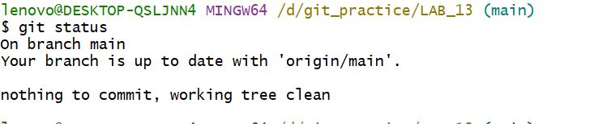

**Part-II: Using git pull**

**12. Git: Now, add a new branch (say nb1) in your repo and add a file in it with any information. This information should NOT be same with any description you added in any of the previous files.**

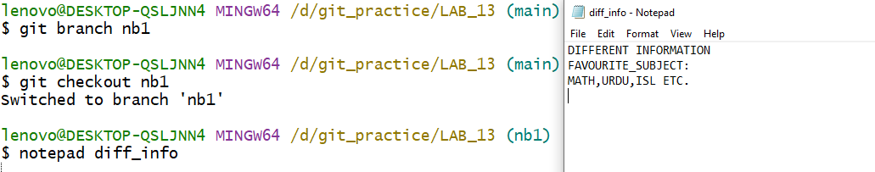

**13.By remaining on the nb1 branch, push this branch and file from git to GitHub**.

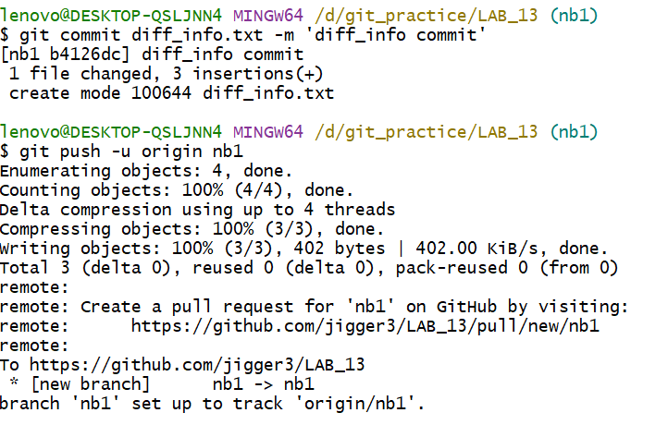

**14.GitHub: make sure all your files and branches have been pushed from git to GitHub.**

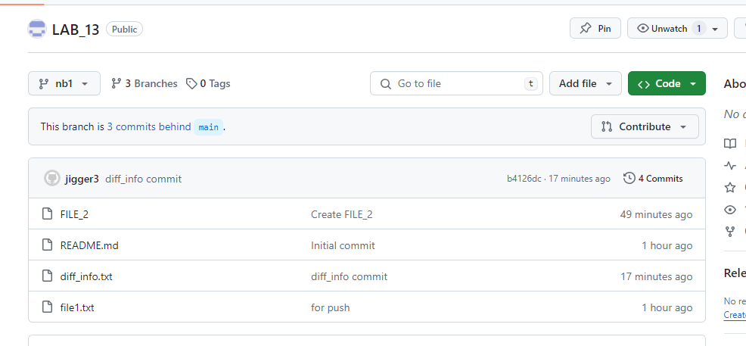

**15.GitHub: make sure all your branches are merged in your master branch i.e. all branches have the same view of the file.**

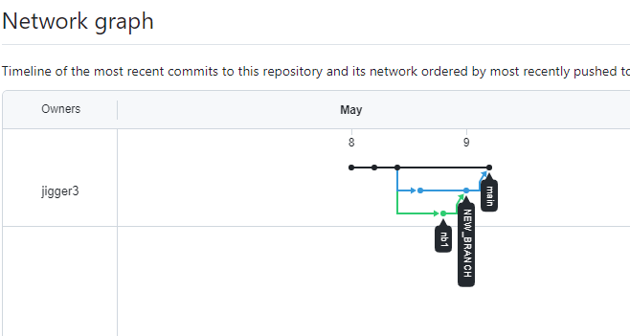

**At this stage, your git and GitHub are up-to-date with each other.**

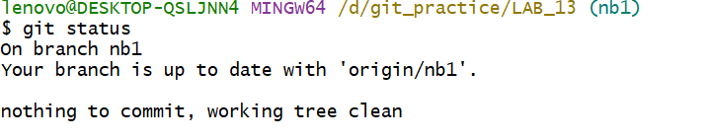

**16. GitHub: now, change any file in any branch (call this branch x) in GitHub. Save and commit that file**

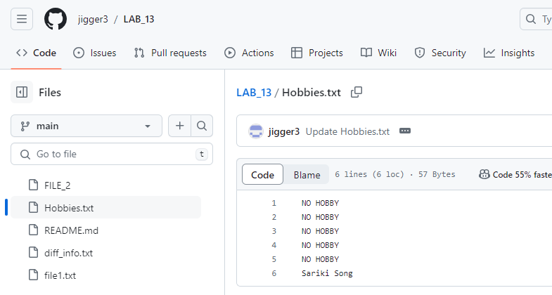

**17. Now, go to branch x in Git and check the status. What is your result?**

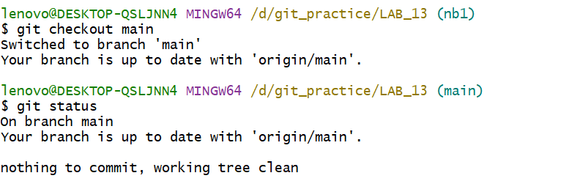

**18. Now apply git pull. This should bring your change (you made in Step 16) to Git.**

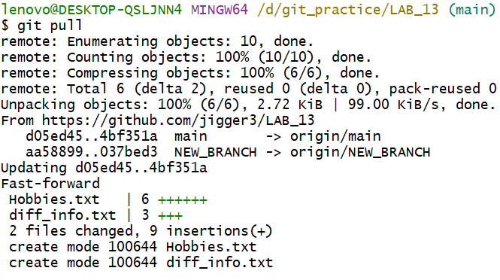

**19. Check the status again.**

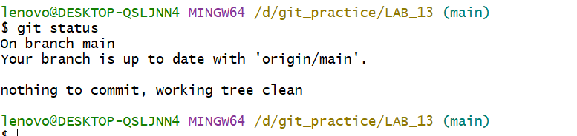

**20. To make sure you are seeing all the commits, apply git log.**

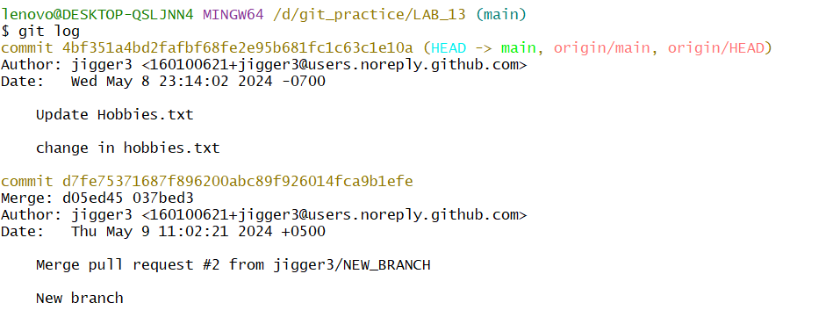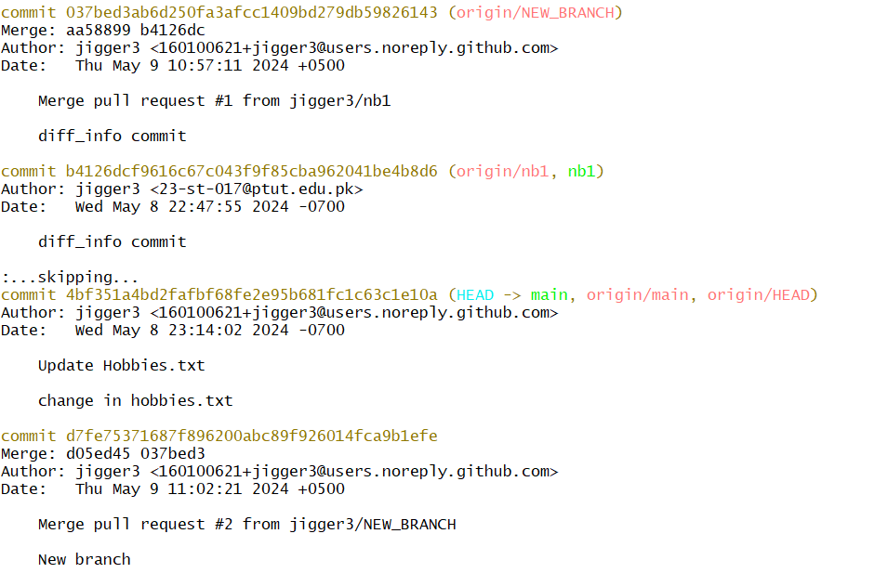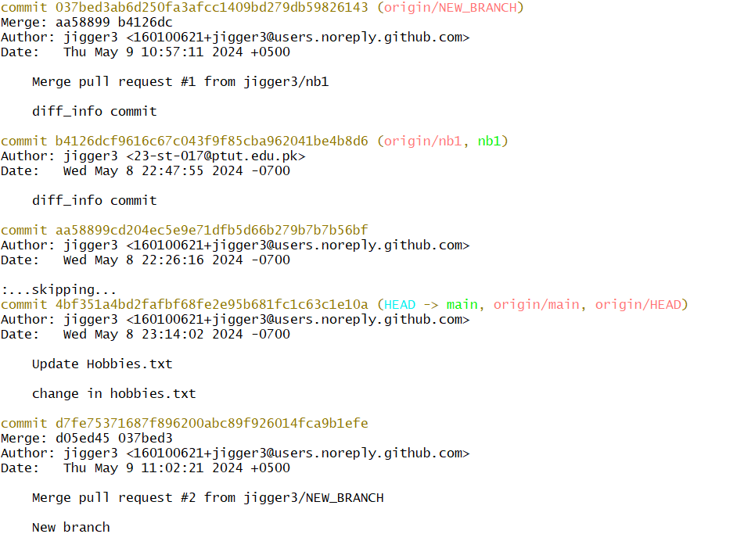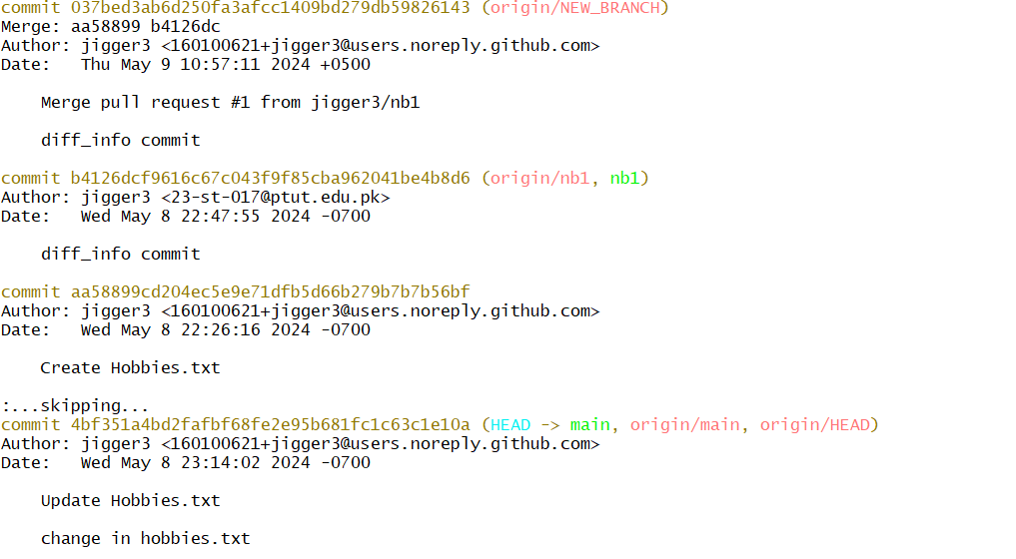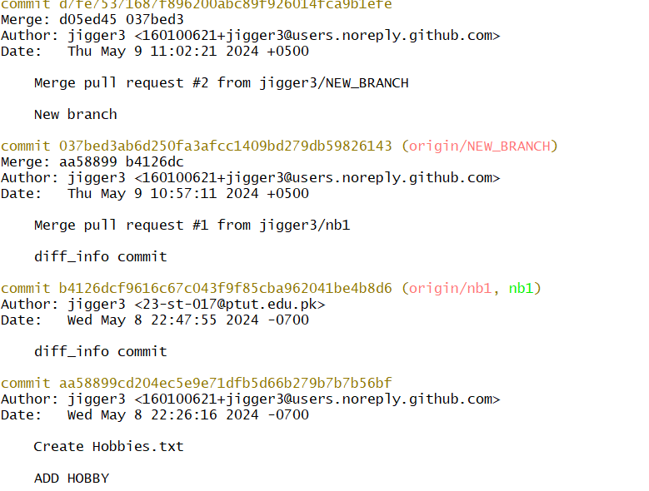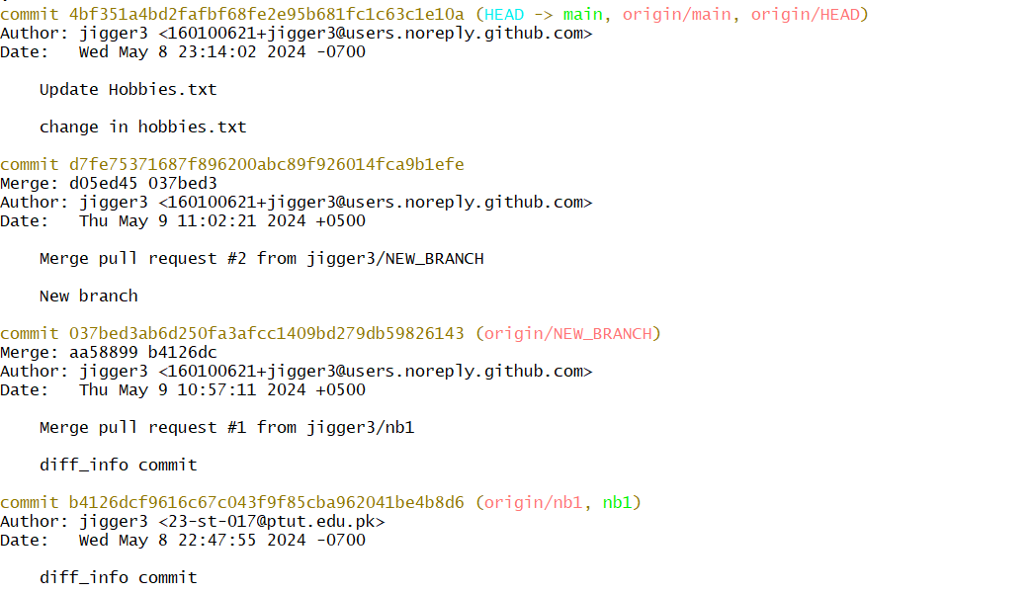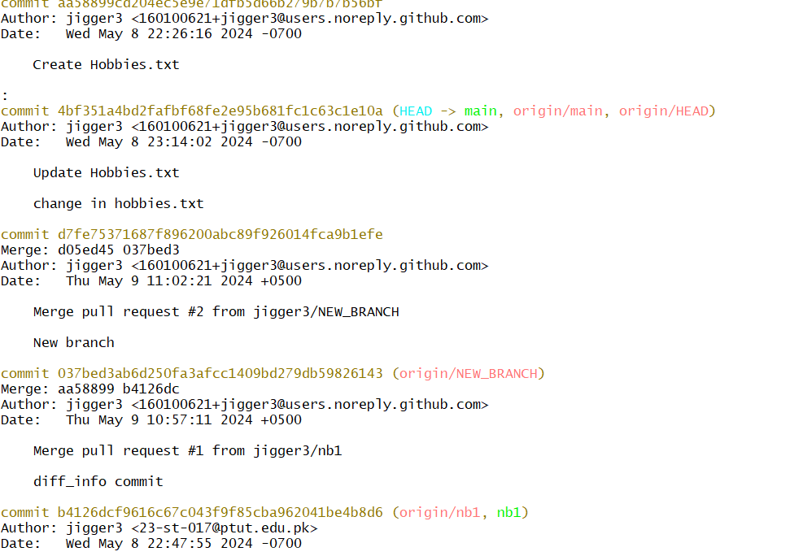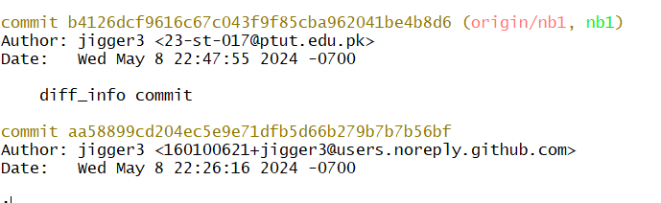

**21. Verify if this log is up-to-date with GitHub.**

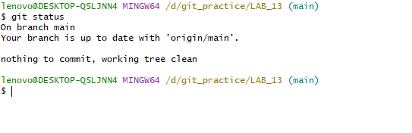

**GENERALIZED LAB RUBRICS**

|  |  |  |  |  |  |  |  |  |
| --- | --- | --- | --- | --- | --- | --- | --- | --- |
| **Domain** | **Component with Taxonomy** | **Above Expectation (4)** | **Meeting Expectation (3)** | **Approaching Expectation (2)** | **Below Expectation (1)** | **Used** | **Weight / 100**  **(Optional)** | **Score (1–4)** |
| **Psychomotor** | **Building (**Hardware) | Is able to build a given setup neatly and timely using correct hardware components and / or can reorganize / adapt to new / special requirements | Is able to assemble a given setup using correct hardware components after minor revisions | Is only able to copy a given setup using correct hardware components | Is not able to assemble a given setup using correct hardware components | ☐ |  |  |
| **Cognitive** | **Recording Measurements** (Hardware / Software) | Is able to record accurate measurements all the time | Is able to record accurate measurements most of the time | Is only able to record accurate measurements on some occasions | Is unable to record accurate measurements | ☐ |  |  |
| **Investigation**  (Software) | Is able to formulate /develop theories in addition to evaluating /concluding correctly about investigation parameters by assessing data | Is able to evaluate /conclude correctly about investigation parameters by assessing data | Is partially able to evaluate  /conclude correctly about investigation parameters by assessing data | Is unable to comprehend investigation parameters | ☐ |  |  |
| **Design / Development of Solution** (Hardware / Software) | Is able to design / develop the solution of a given problem and add features to it | Is able to design / develop the solution of a given problem | Is able to partially design / develop the solution of a given problem | Is unable to partially design  / develop the solution of a given problem | ☐ |  |  |
| **Software Usage**  (Software) | Is adept in the use of software tool and can access advanced features | Is able to use the software tool effectively by accessing all the required features | Is able to use the software tool but cannot access all the required features | Is unable to use the software tool | ☐ |  |  |
| **Programming Language** (Software) | Is able to efficiently complete a given task using advanced programming language constructs / methods / commands and/or add features to the original task | Is able to complete a given task using required programming language constructs / methods / commands | Is able to partially complete a given task | Is unable to partially complete a given task | ☐ |  |  |

**NAME: MUHAMMAD KHIBAIB**

**ROLL NO: 23STO17**

**DEPARTMENT: SOFTWARE ENGINNERING TECHNOLOGY**

**LAB14**

**PART-I: Pushing from Git to GitHub**

**1. In GitHub, fork the hackeruser240/SCM-Spring2024 repo.**

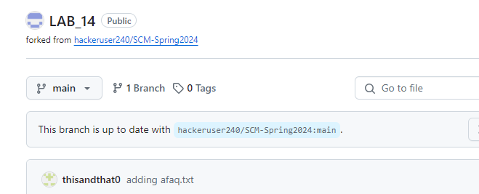

**2. Confusing: Go in git and clone your own forked version of hackeruser240/SCM-**

**Spring2024. Your link should look like this:**

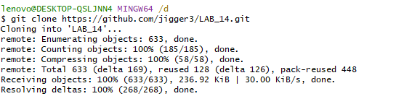

**3. Do git status. Your status should be clean.**

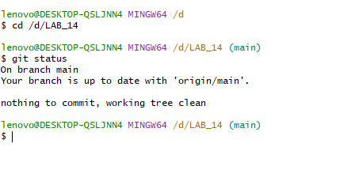

**4. If you need to set the origin, you will do it by: git remote set-url origin <set_url>**

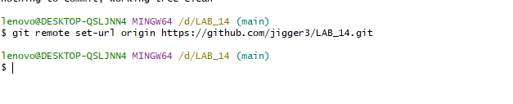

**5. In git, go to main branch and add a new file in that branch.**

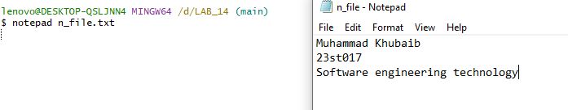

**6. Save the file, stage it, and then commit it by adding a meaningful commen**

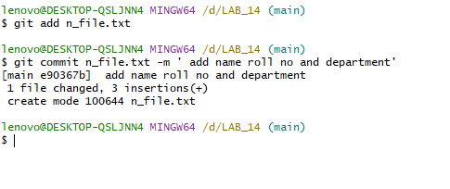

**7. Now, do git status. What result do you get? Hint: You status should not be ‘everything up-to-date’**

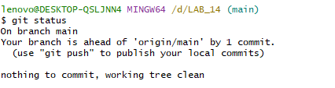

**8. Caution: Push your code to origin (GitHub) by running the following command Git push origin -u <branch_name>.**

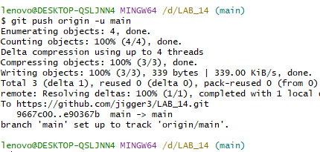

**9. In GitHub, you will see a message pop-up in yellow background. Attach its screenshot.**

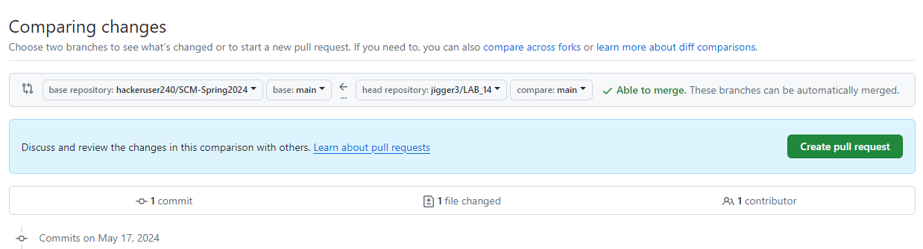

**You should a figure something like this:**

**10. With reference to Step 9, create a Pull Request (via 1 or 2 in the above figure) and submit.**

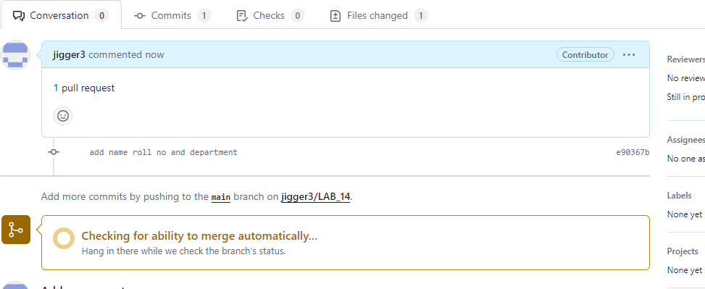

**11. Attach your network graph.**

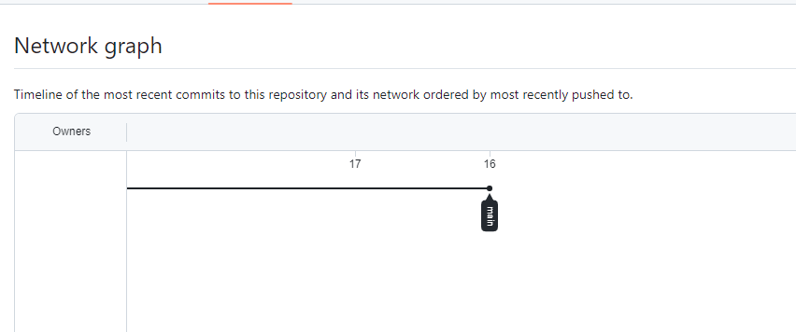

**PART-II: Creating a branch & pushing it to GitHub**

**12. In git, create a new branch and add a new file in it (this file is different from Step 5 file)**

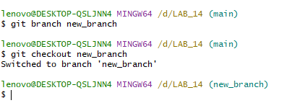

**13. Add any information to it. DO NOT COPY FROM EACH OTHER.**

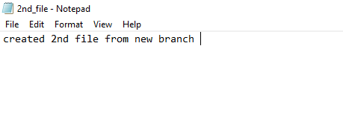

**14. Save it, close notepad (or VS Code), stage it, and finally commit it using a meaningful comment.**

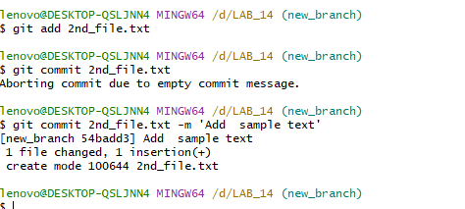

**15. Push this branch to GitHub.**

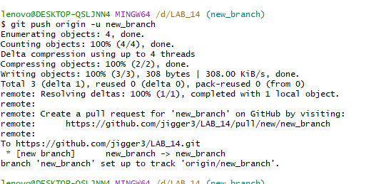

**16. Check git status.**

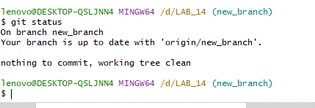

**17. On GitHub, make sure that the branch you have pushed is begin showed. You may have to refresh the page.**

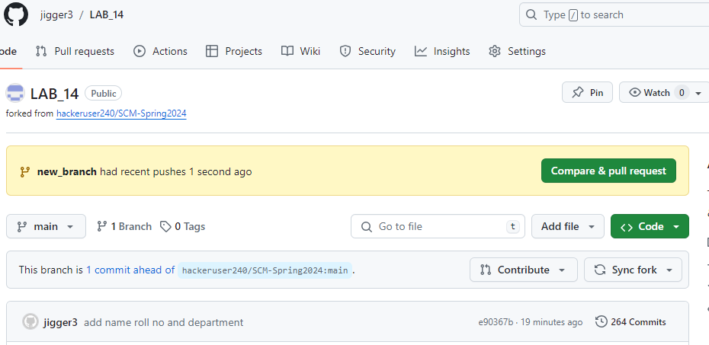

**18. Caution: Create a pull request to merge this new branch (of your forked repo) into the main branch (of the original repo). If you do not see your change, you will have to troubleshoot your problem.**

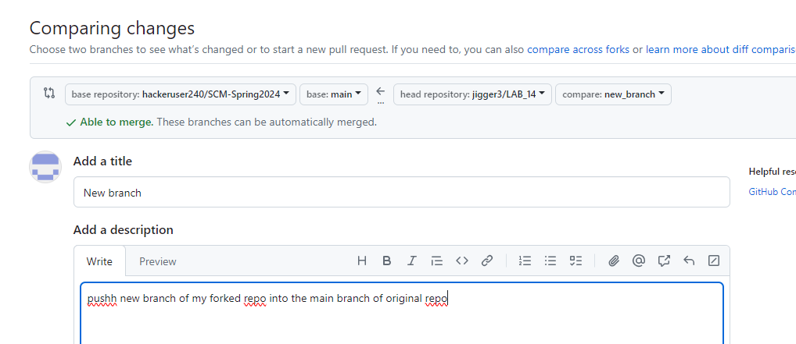

**PART-III: Pulling changes from main branch GitHub**

**19. In your forked repo in GitHub, go to the main branch.**

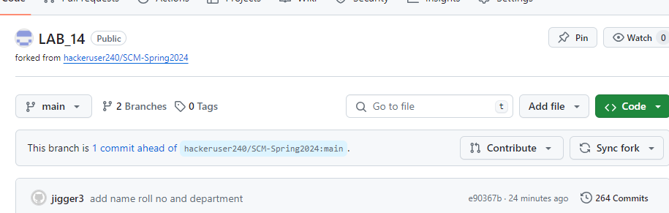

**20. Go to any file in the main branch and add any change you like. Commit the changes to that file in the main branch.**

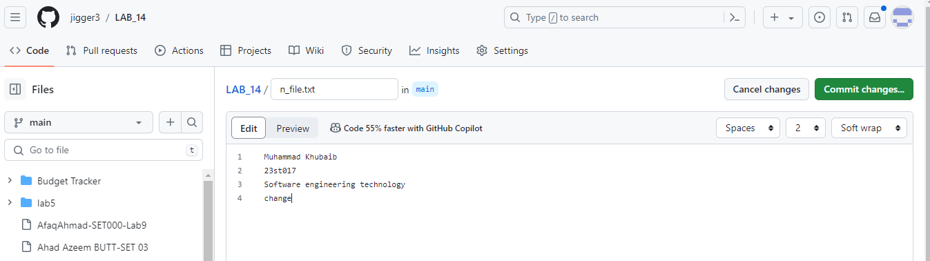

**21. Go to git and check the status. You should be some different i.e. there should be some change in your git and github.**

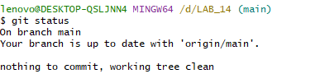

**22. In github, you should see the ‘Commit’ tab. Open the commits and attach a screenshot of the list of commits made.**

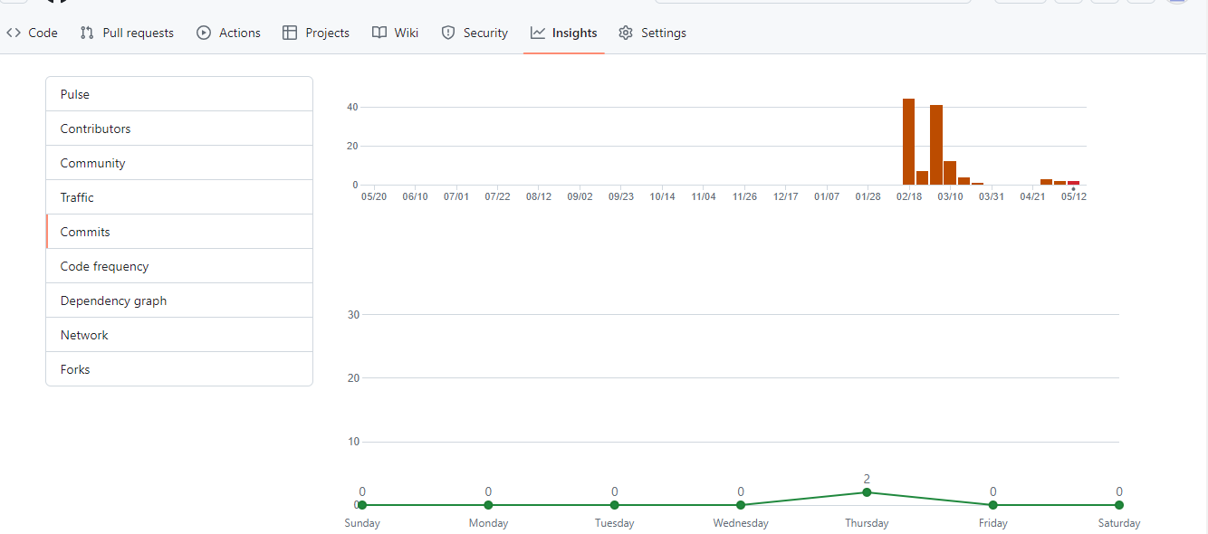

**23. Now, go to git and do git fetch on your main branch. You should get some result. If you do not see some result, you have done something wrong. Troubleshoot your problem.**

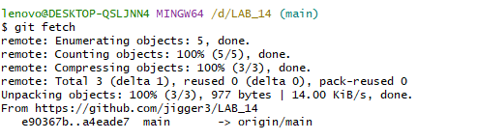

**24. Do git merge.**

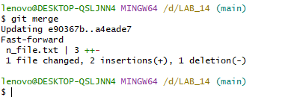

**25. Again, do git status. Your git repo should be up-to-date.**

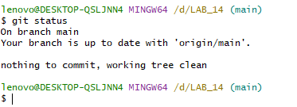

**26. Open your file (the file of Step 20) and verify if the change you made in Step 20 has been updated in your local repo.**

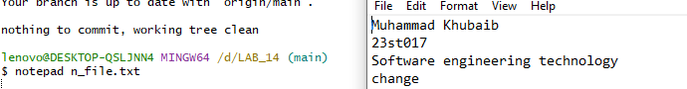

**27. Do git log. The list should be the same as Step 22.**

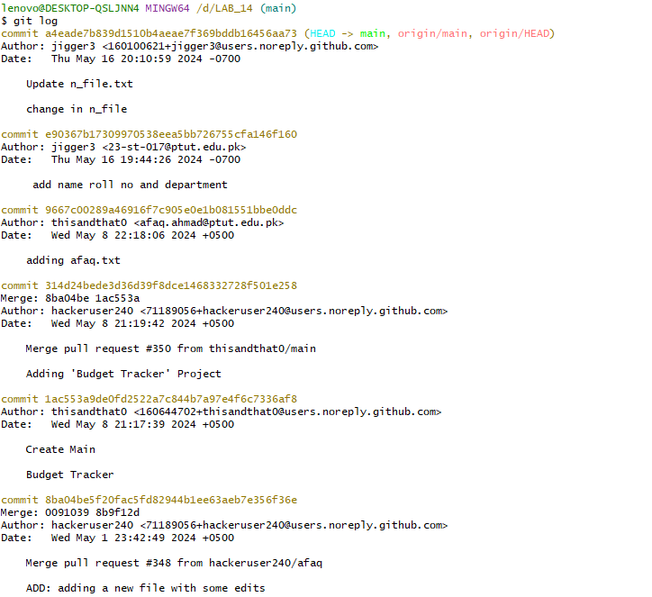

**28. In github, create a new branch from main and add a new file with any information.**

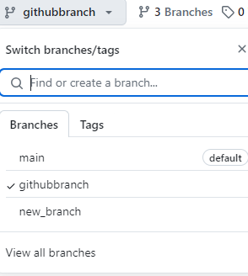

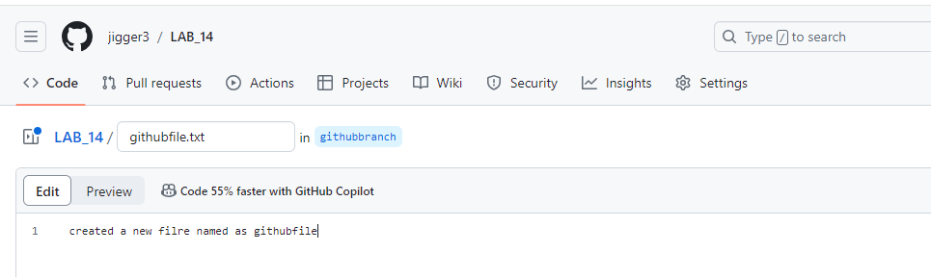

**29. In git, go to you main branch and do git fetch.**

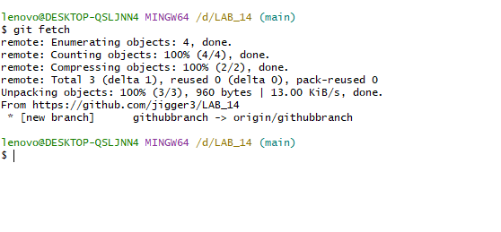

**30. To view the list of branches, execute the command: git branch –a Note that the -a option indicates all the branches in git and github.**

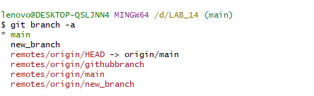

**31. You should see the Github branches in red color.**

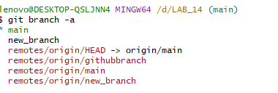

**32. Go to the new branch in Git using git checkout.**

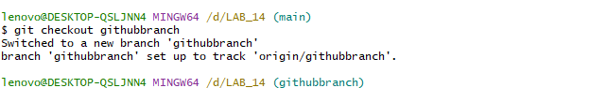

**33. Finally, on the new branch, check the contents of the branch using dir command. Attach a screenshot.**

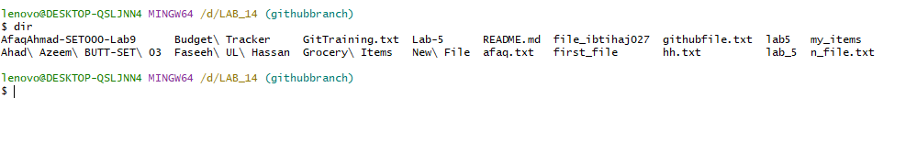

* **18 files show.**

**34. To verify this, go to github and navigate to the same branch. Attach a screenshot of the contents of that branch. These contents should be the same as Step 33.**

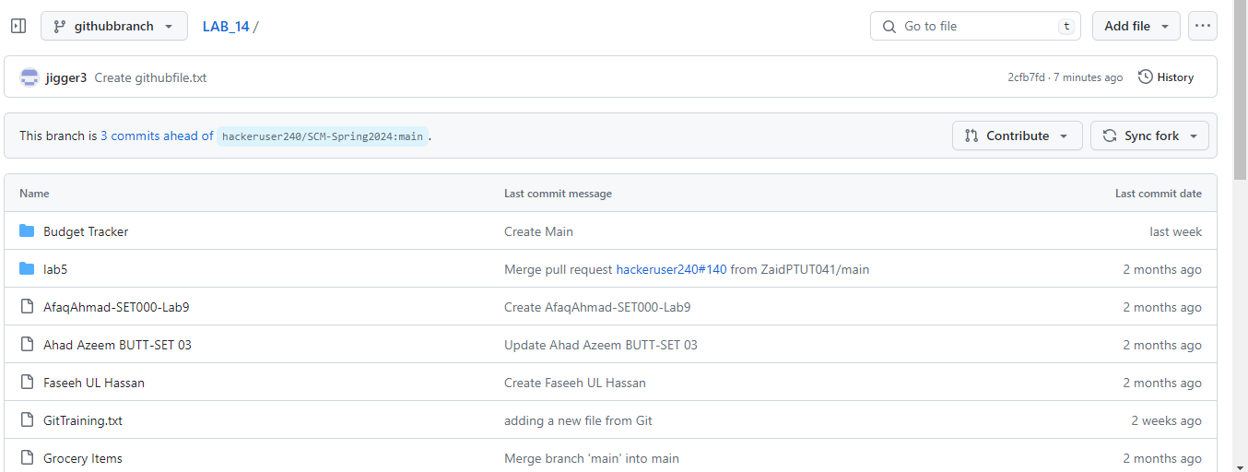

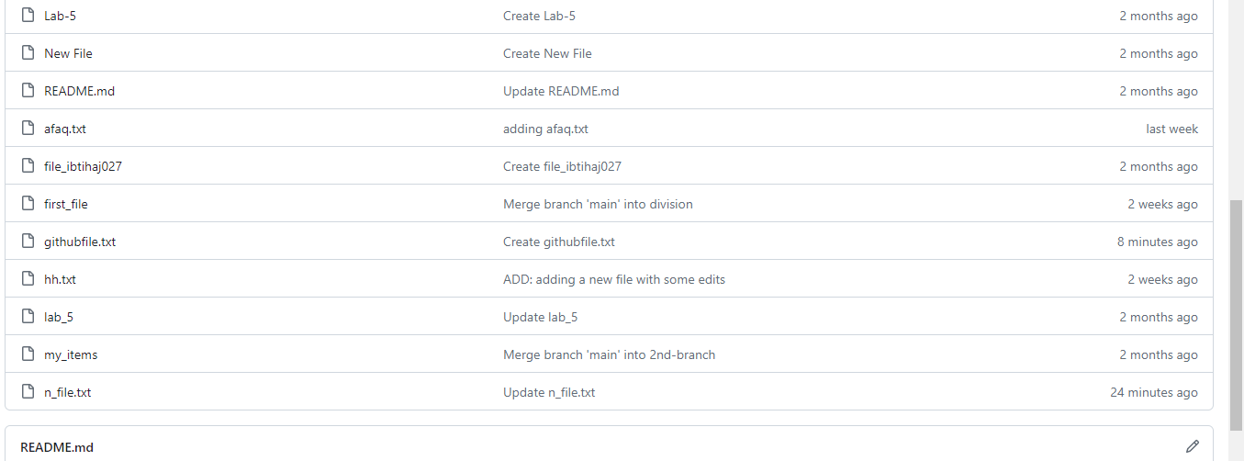

* **18 files show.**

**GENERALIZED LAB RUBRICS**

|  |  |  |  |  |  |  |  |  |
| --- | --- | --- | --- | --- | --- | --- | --- | --- |
| **Domain** | **Component with Taxonomy** | **Above Expectation (4)** | **Meeting Expectation (3)** | **Approaching Expectation (2)** | **Below Expectation (1)** | **Used** | **Weight / 100**  **(Optional)** | **Score (1–4)** |
| **Psychomotor** | **Building (**Hardware) | Is able to build a given setup neatly and timely using correct hardware components and / or can reorganize / adapt to new / special requirements | Is able to assemble a given setup using correct hardware components after minor revisions | Is only able to copy a given setup using correct hardware components | Is not able to assemble a given setup using correct hardware components | ☐ |  |  |
| **Cognitive** | **Recording Measurements** (Hardware / Software) | Is able to record accurate measurements all the time | Is able to record accurate measurements most of the time | Is only able to record accurate measurements on some occasions | Is unable to record accurate measurements | ☐ |  |  |
| **Investigation**  (Software) | Is able to formulate /develop theories in addition to evaluating /concluding correctly about investigation parameters by assessing data | Is able to evaluate /conclude correctly about investigation parameters by assessing data | Is partially able to evaluate  /conclude correctly about investigation parameters by assessing data | Is unable to comprehend investigation parameters | ☐ |  |  |
| **Design / Development of Solution** (Hardware / Software) | Is able to design / develop the solution of a given problem and add features to it | Is able to design / develop the solution of a given problem | Is able to partially design / develop the solution of a given problem | Is unable to partially design  / develop the solution of a given problem | ☐ |  |  |
| **Software Usage**  (Software) | Is adept in the use of software tool and can access advanced features | Is able to use the software tool effectively by accessing all the required features | Is able to use the software tool but cannot access all the required features | Is unable to use the software tool | ☐ |  |  |
| **Programming Language** (Software) | Is able to efficiently complete a given task using advanced programming language constructs / methods / commands and/or add features to the original task | Is able to complete a given task using required programming language constructs / methods / commands | Is able to partially complete a given task | Is unable to partially complete a given task | ☐ |  |  |